[Insert CM Firm’s Logo Here]
University of Michigan
Name of Project
UM Project No. P0000xxxx
Construction Manager’s Quarterly Construction Summary
Construction Manager: [Name]
Architect: [Name]
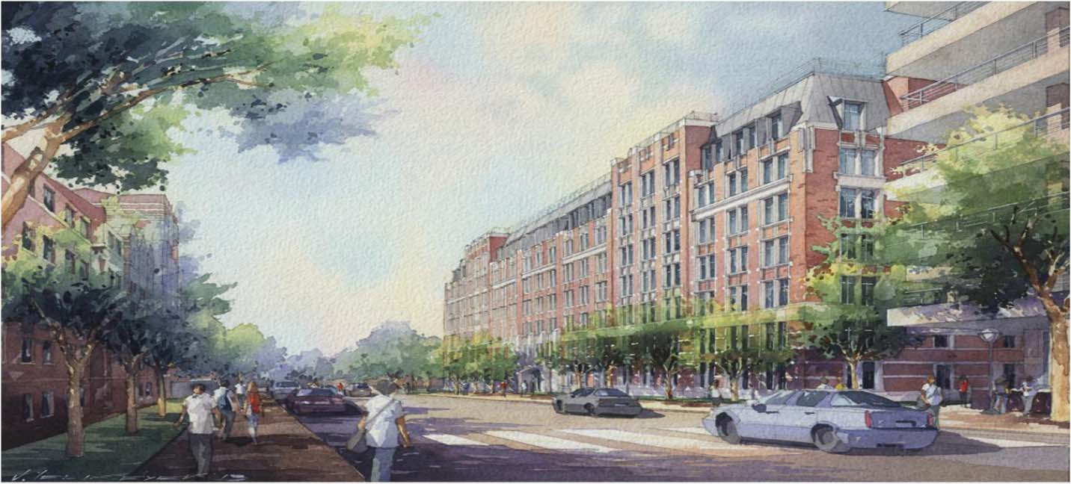

[At the start of the project, insert the A/E's rendering here and provide photo credit. Once there has been significant construction progress, the rendering may be replaced with a site progress photo. If possible, use the same perspective as the A/E rendering.]
PROGRESS OVERVIEW
- Summarize the general progress in narrative form.

CRITICAL ISSUES
- List schedule or budget issues and detail how issues are being addressed. Or, indicate "None at this time."

SAFETY
1) Description of CM firm’s safety mission statement/motto.
2) Insert image of U-M safety report from the last month of the reporting quarter. Do not include any other charts or graphs.

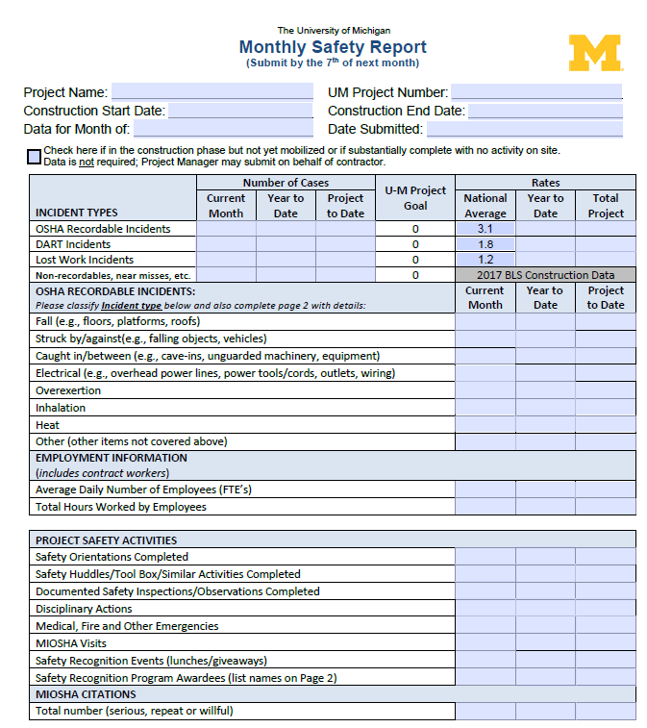
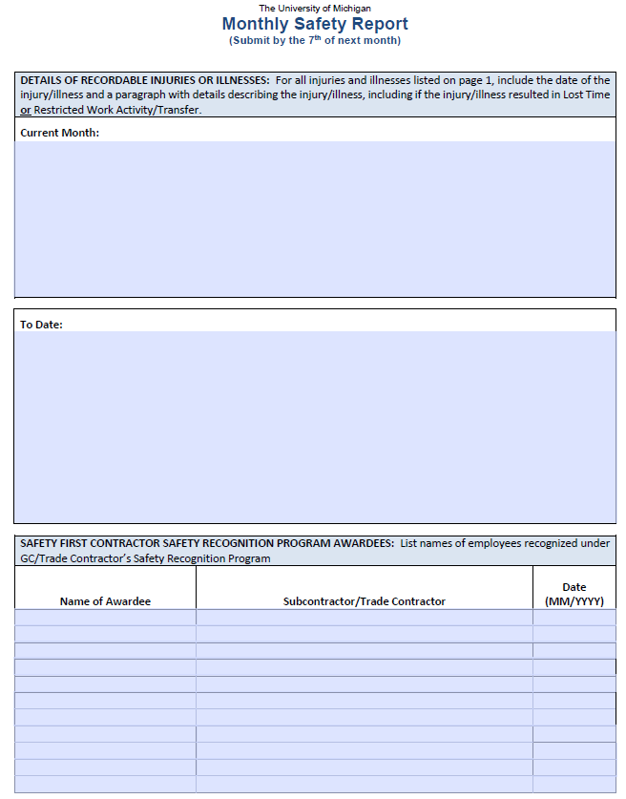

DIVERSITY BUSINESS PARTICIPATION

Trade Name | Contract Amount
If no awards, indicate "Nothing to report at this time." | $

SCHEDULE OVERVIEW
Do not provide a bar chart or other graphic.

Construction is [%] Complete through [Date/Month].

Bid Document Release Dates from Design Professional to CM  per the CM SOPD |  |  |  |  | Out to Bid
Bid Package No. | Description | Original Schedule per SOPD | Current Schedule | Actual |  | Original Schedule | Current Schedule | Actual
DR #0 | Demo and Abatement | 8/23/19 | 8/2/19 | 8/2/19 |  | 8/5/19 | 8/5/19 | 8/5/19
DR #1 | Precast Concrete design-assist & installation | 7/8/19 | 7/8/19 | 7/8/19 |  | 6/28/19 | 7/16/19 | 7/16/19
DR #2 | Earth Retention Systems | 9/24/19 | 9/24/19 | 9/24/19 |  | 10/22/19 | 10/2/19 | 10/26/19

MILESTONES
List milestones listed in CM SOPD and any other milestones determined by the Project Team at the beginning of the project.

Description | Original Schedule per SOPD | Current Schedule | Actual
Start of Demolition | 9/23/19 | 9/23/19 | 9/23/19
Start of Precast Concrete | 3/17/20 | 3/17/20 | TBD
Building Enclosure | 11/22/20 | 11/22/20 | TBD

3-MONTH OUTLOOK

Month/Year | Month/Year | Month/Year
- Continue precast concrete fabrication  - Begin precast installation  - Complete concrete foundations and walls  - Continue earthmoving operations and backfilling | - Continue precast concrete fabrication  - Begin precast installation  - Complete Madison Street water line install  - Begin masonry installation | - Continue precast concrete  - Begin basement underground piping installation  - Begin window installation  - Begin layout of basement walls

ADDITIONAL MEASURABLES (reported in business days)
If review time exceeds goal, provide an explanation.

RFI Review: | Submittal Review: | Change Management: | Pay Applications:
Total RFI’s: | Total Submittal Packages: | Total No. of CCDs: | Total Pay Apps:
Avg. Review Time: | Avg. Review Time: | Avg. CCD to CO: | Avg. Payment Time to CM:
Review Time Goal: | Review Time Goal: | Goal for CCD to CO: | Payment Goal U-M to CM:
 |  |  | Avg. CM Payment to Trade:
 |  |  | Payment Goal CM to Trade:

Budget/Cost Status: Invoice Summary
Insert the invoice summary from the last month of the reporting quarter.

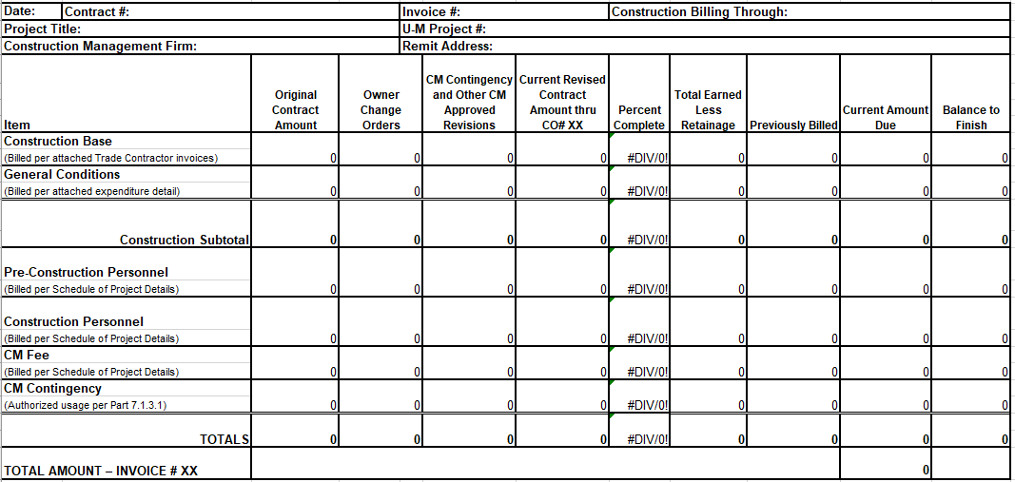

Construction Cash Flow
If the actual varies significantly from the projection, provide an explanation.

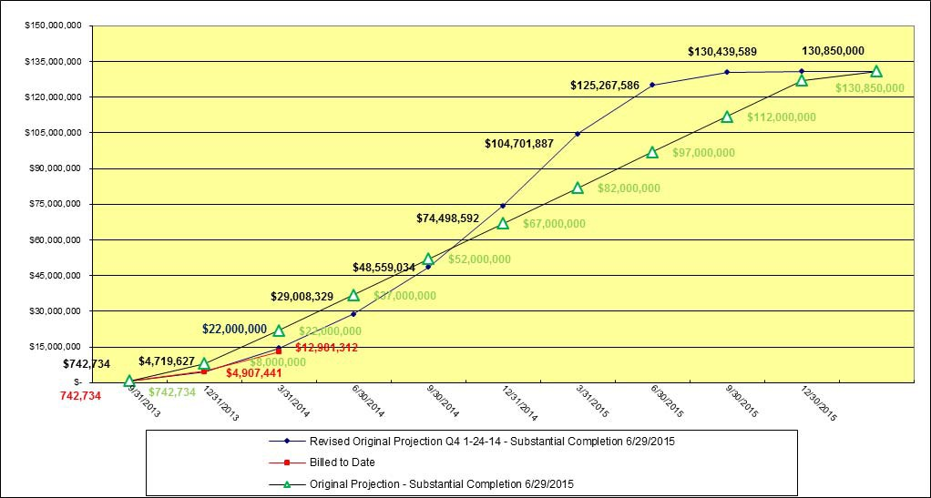

SUSTAINABILITY & ENVIRONMENT
Narrative of CM’s Sustainability and Environmental program.

PROGRESS PHOTOGRAPHS
Insert photos and include dates taken and brief description.

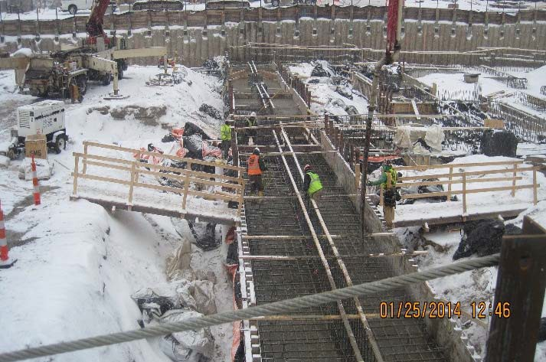  Concrete footing installation | 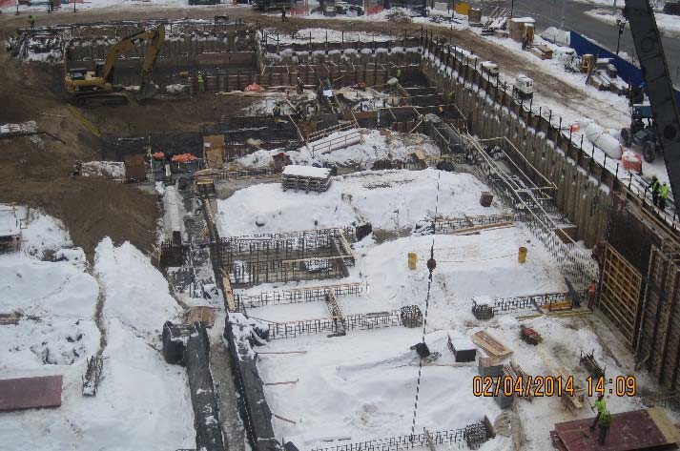  Foundations looking southwest
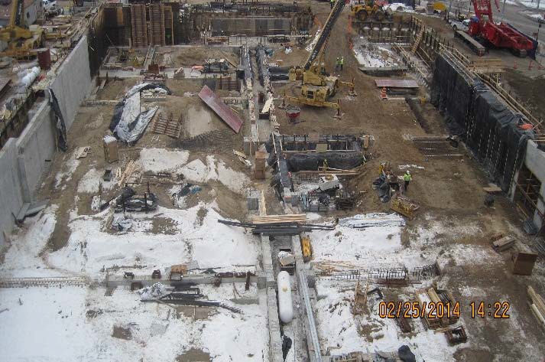  Foundations looking south | 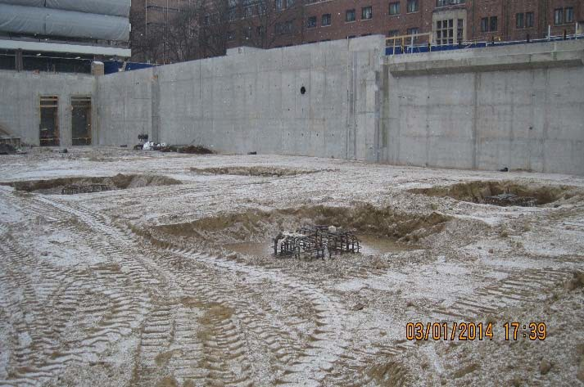  Complete foundations backfilled

