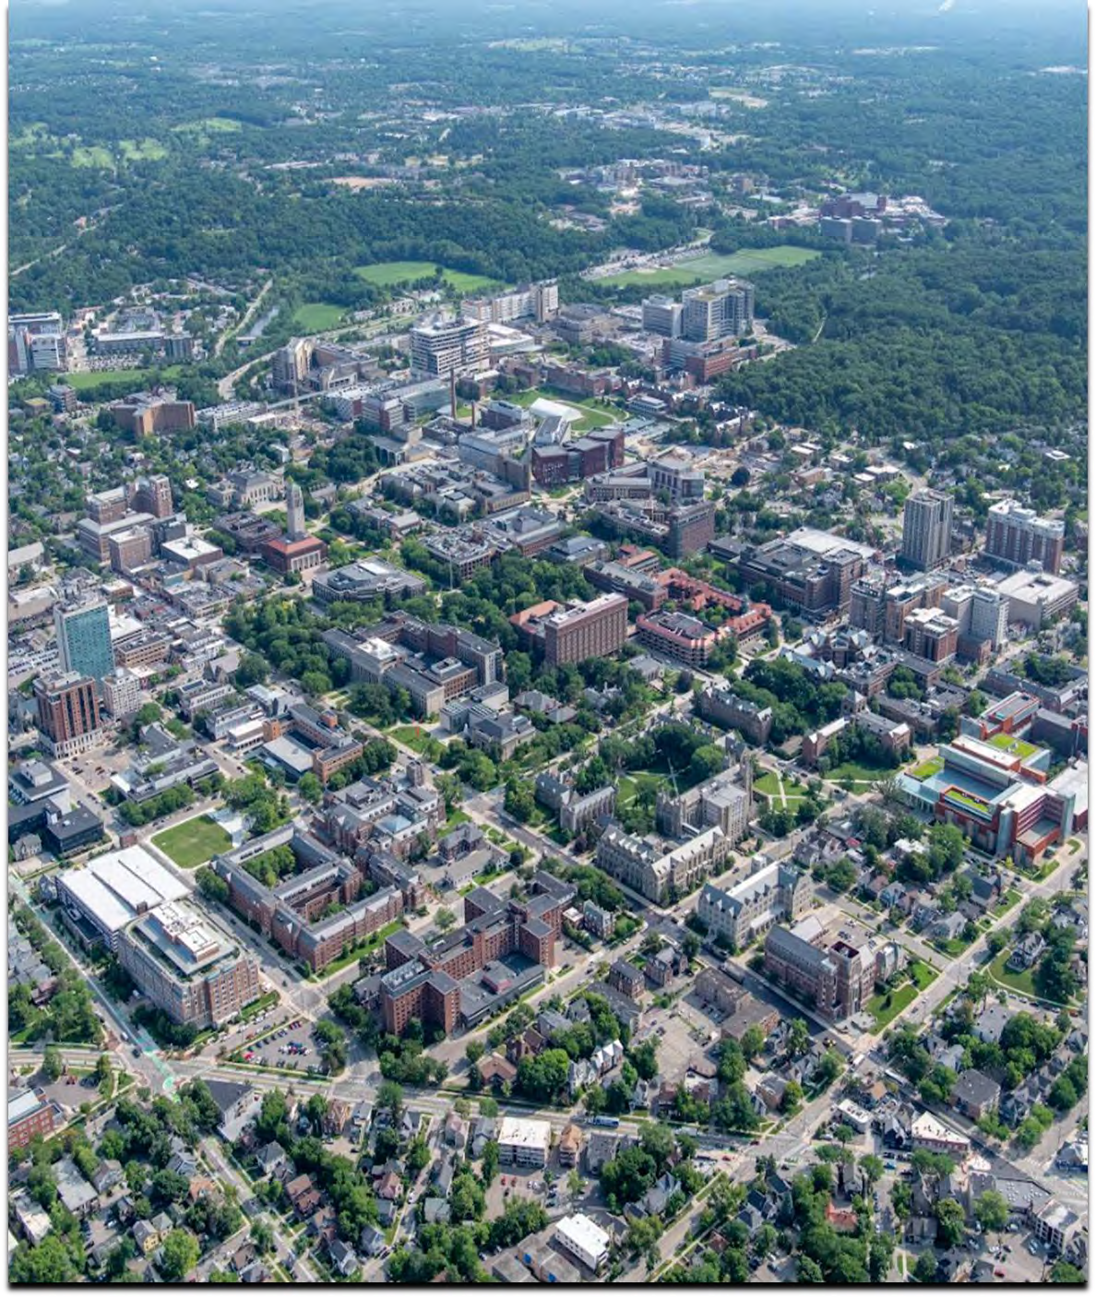
User’s Guide to Capital Projects

for AEC Managed Projects



Table of Contents
Executive Summary 4
Capital Projects Stakeholders 6
Capital Projects Approval 10
Project Delivery Methods… 12
Design Professional Selection 13
Initiation and Pre-Design Phase 14
Budgets and Estimates 16
Design Phase 18
Construction Phase 21
Closeout Phase 27
Factors that Influencing Project Costs 28
Definitions 32
Appendices 34
Design Phases and Typical Tasks 35
Project Delivery Methods… 36
Project Goals Template 38
User Satisfaction Evaluations 39
AEC Website References: Design Deliverables Project Estimates Contracts and Agreements Design Guidelines
Safety Program


The capital projects process is a collaborative effort with many stakeholders representing collective interests. The sponsor or user advocates for the project by representing the user’s needs and goals. The department of Architecture, Engineering, and Construction (AEC) has been delegated various levels of authority and many responsibilities to ensure that projects managed by AEC meet approved guidelines and standards, and are aligned with the university’s mission. Early goal setting among stakeholders is critical in order to clarify scope and establish a common framework for making informed decisions.
This user’s guide has been developed to provide a condensed explanation of the University of Michigan’s AEC process for delivery of capital projects and to document and communicate important information needed to effectively complete projects.
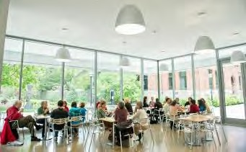
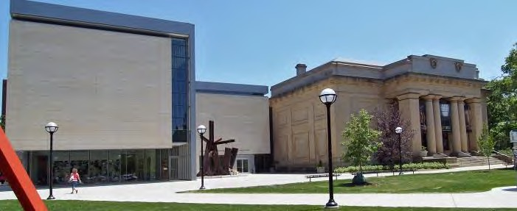
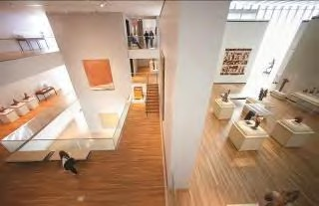
University of Michigan Museum of Art interior
HONOR AWARD FOR ARCHITECTURE
University of Michigan Museum of Art

Executive Summary

USER’S GUIDE TO CAPITAL PROJECTS
As University of Michigan buildings can endure for many years without significant renovation, engagement with the capital projects process may be infrequent for many units. This guide serves as important source of information and use of the established processes assists project teams in making decisions that help projects meet required parameters and reduce university risk.
U-M undertakes capital projects each year to renovate existing buildings and construct new buildings to meet its strategic goals, and these projects demand great investments of university resources. Therefore, effective management is essential and requires rigorous processes with appropriate controls to ensure the most efficient use of resources. These processes, which are fully detailed in the Department of Architecture, Engineering and Construction’s (AEC) procedure manuals, have been created to ensure that projects managed by AEC meet many objectives including: align with the university’s academic mission; satisfy the user’s needs; meet approved guidelines for design, sustainability, and quality; are completed within budget and on schedule; and are constructed with safety as the first priority.

OVERVIEW OF PROCESS
In general, the capital project process begins with the project sponsor gaining approval from university leadership to initiate.
With the approval of university leadership, the project moves into a pre-design phase. This effort produces a program (written description), and a conceptual design (graphics), including a schedule and estimate of the construction work. During the pre-design effort, design managers and planners work from the defined goals to develop a program and balance the competing objectives of scope, budget, and schedule. At this stage, a project delivery method is finalized. With a budget, a schedule, and funding source identified, the project is ready to begin a formal design effort. Projects over $5 million are presented to the Board of Regents for project approval.
The project team then proceeds to design, during which AEC’s design manager directs a design professional (architects and engineers) to work with the project team from the defined scope and budget to develop the design
phases, verifying the budget at each phase, and then producing construction drawings and specifications. The design effort for a major project can range between one to one and one-half years, depending upon the size and complexity. During the design effort of a project, approvals are gained from various authorities and for major projects, concludes with a Regents’ authorization to issue a project for bids and awarding construction contracts. An abbreviated list of steps and significant tasks in each phase of a major project is presented in the appendices.
During construction, AEC’s project manager works with a team of contractors that builds from the instructions contained in the construction documents to physically assemble the specified materials and equipment. Construction of a major project can last several years, depending upon the size and complexity. In the activation phase, the facility is turned over to the occupants and the corresponding maintenance department. In this phase, furniture and user-owned equipment is installed, occupants move in, and minor unfinished items (the punch list) are completed by the contractors. The last and final stage is not as noticeable by most team members. This is where financial closeout occurs during which the contracts are closed and remaining funds are returned to the user or the funding source.

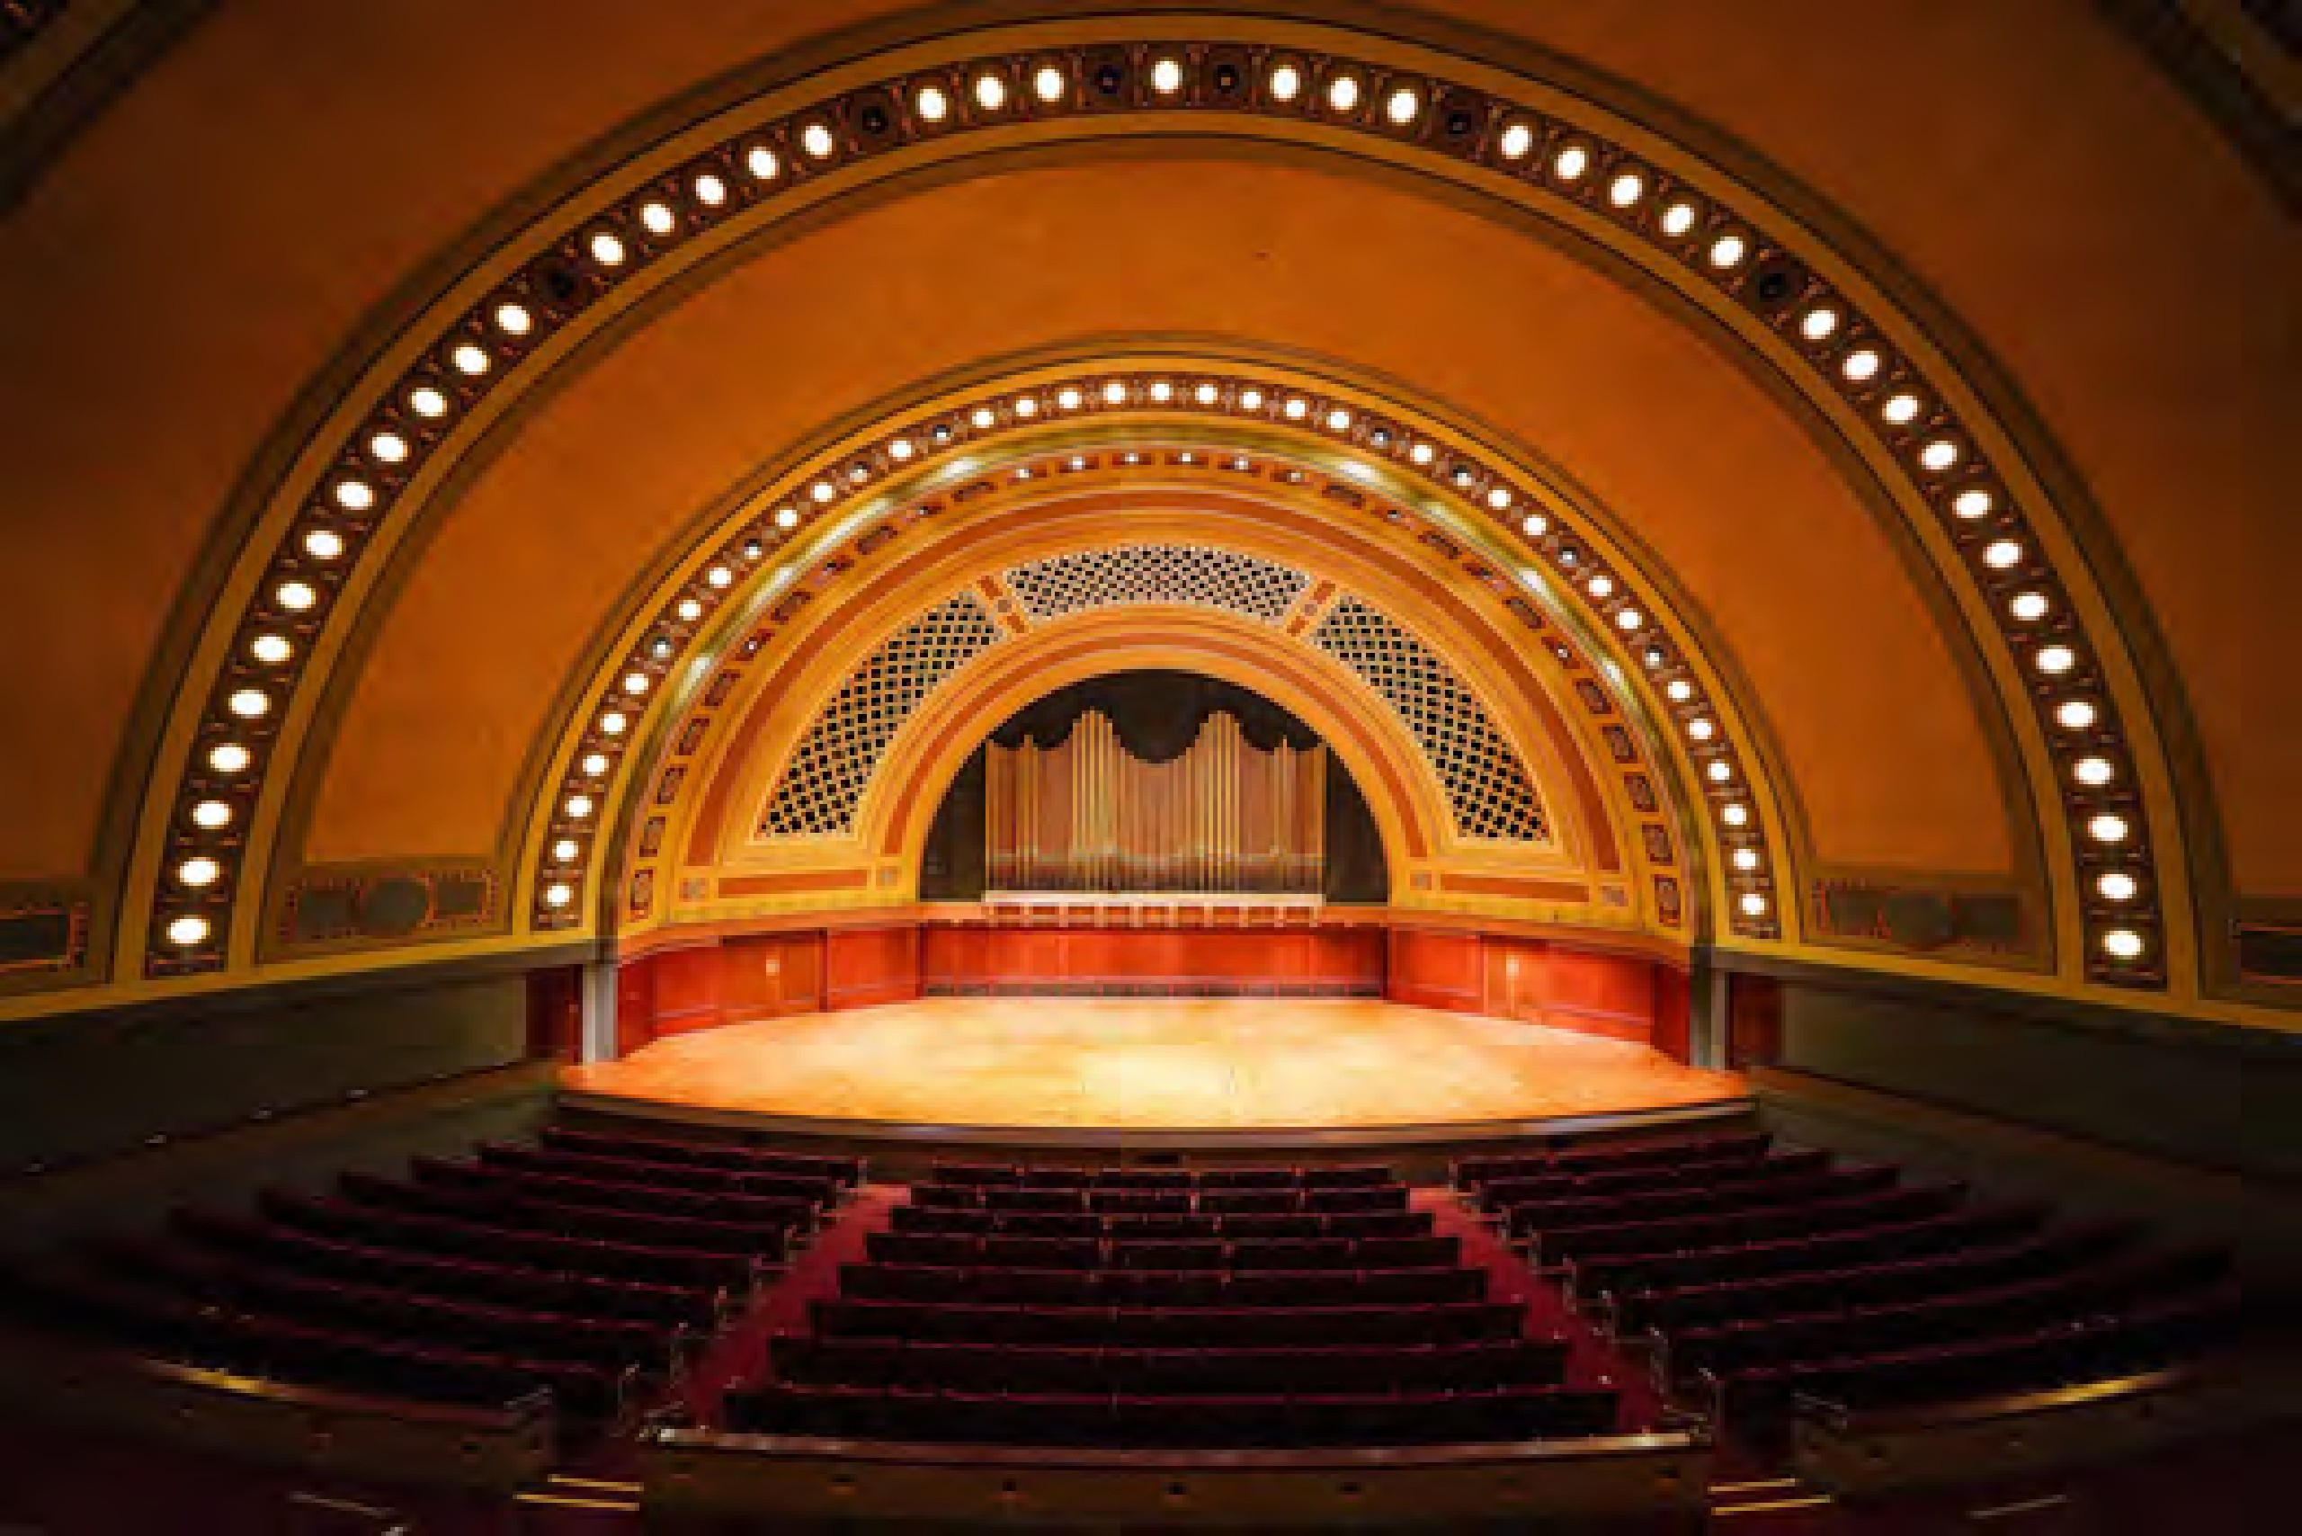
Hill Auditorium

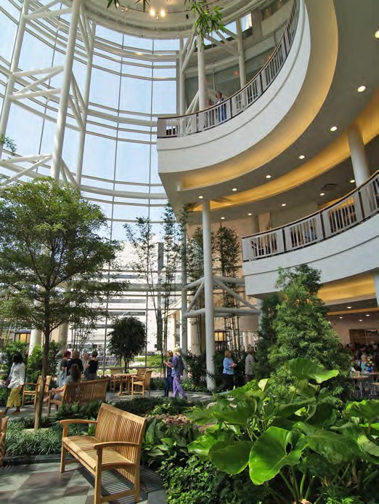
PROJECT TYPES
Samuel and Jean Frankel Cardiovascular Center

In general, there are three types of projects – major, mid-size and small. Major projects are those that consume the most university resources and consequently require the greatest oversight. Because these projects require the most intensive planning and design, they must go through every step of each phase and therefore take the longest to complete. Projects with budgets of more than $10M are considered to be major projects. Midsize projects are less complex and can bypass some steps, which will vary from project to project. Midsize projects typically have budgets between $5M and $10M. Small projects may move fastest through the process, bypassing some steps and tasks within each phase. The planning phase can often be significantly condensed without sacrificing quality. These projects have budgets of less than $5 million.
Most capital projects are required to follow the capital projects process described on page 10 of this guide, although there are some exceptions. The distinguishing factor is typically based on the estimate cost of the project and/or the impact to the broader campus.

MAJOR PROJECT MILESTONES FOR DESIGN-BID-BUILD DELIVERY METHOD

Initiation Depending on user funding | User identifies capital project need User requests project  Approval received by U-M Leadership
Pre-Design 4-6 months | Design Professional selected, program verified and benchmarked Regents approve project and architect appointment
Design  12-18 months | Schematic design is developed; cost estimates and schedule updated Regents approve schematic design and proceeding with construction  Design continues to construction documents; cost estimates and schedule updated
Construction 12-24 months | Bid and award construction contracts-provided bids are within budget Construction, commissioning  Project closeout and user occupancy

Capital Projects Stakeholders

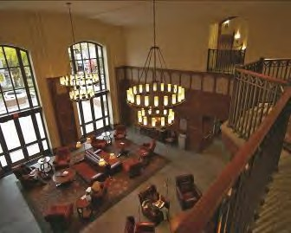
Weill Hall

Capital projects involve many stakeholders: U-M units, outside design professionals, contractors, consultants, governmental agencies, and many others. Therefore, project teams are normally large, and the process from inception to completion of projects is complex.
The University of Michigan Standard Practice Guide (SPG) is an overview of the general operating policies and procedures of the university and delineates the executive vice president and chief financial officer (EVPCFO) as having the responsibility for the physical properties of the university. Facilities and Operations departments report to the EVPCFO and are the delegated authority to ensure that the university safeguards the university’s physical assets and fulfills its legal obligations.
The responsibilities delegated to AEC by the EVPCFO primarily consist of the management of the design and construction activities of assigned projects by university leadership. According to the Standard Practice Guide 601.24, architectural and construction services are considered restricted commodities and require special approval.
Projects managed by U-M Health, the Office of Planning and Strategic Initiatives, and Real Estate are excluded from AEC’s oversight.

AEC
AEC is responsible for managing the design and construction activities for assigned university capital construction projects. AEC also provides general professional services to support various university departments.
This guide focuses on the capital construction process for
new or renovation projects. The primary project management responsibilities include selection of consultants and construction contractors, and leadership throughout all stages of design and construction through final occupancy.
AEC uses a cross-functional team approach in managing projects. The project team includes all members necessary to meet the objectives of those who will ultimately occupy the space being created or renovated by the project. The team must also meet the requirements of the university leadership, meet the parameters of the university planning principles, and deliver the project within the established safety, budget, and schedule goals, and the design quality parameters defined in the university’s design guidelines. The members of the cross
-functional teams come from the different areas of AEC. The major areas and their roles are described below.
Planning: AEC’s Planning and Communication Office (PAC) oversees campus and site planning and manages the review of certain exterior elements including signage, furnishings, public art, and lighting. In addition, interactions with the City of Ann Arbor for activities conducted within AEC are coordinated through PAC and all communication to the Ann Arbor and campus community.

Design Management: The design managers within AEC are responsible for the activities and design deliverables of the pre-design and design phases. The design manager is the lead and focal point for administration of the project during design, addressing overall design, change management issues, quality control, budget, schedule, and communication with the user and other affected university departments. In addition, AEC self performs design functions for most small and some midsize projects.

MISSION AND VISION

The mission of AEC is to deliver efficient, productive and responsive professional services to create the most functional and enriching environment for the University community.

Our vision is to be the benchmark of excellence for facilities planning and construction for higher education.

Construction Management: The construction management group consists of project managers that are responsible for development of construction execution strategies and for the construction phase through project closeout. The project manager is the lead and focal point for administration of the project during construction, addressing safety, change management, quality control, budget, schedule, and communication with the user and other affected university departments.
Project Directors: Project directors are assigned to the most complex major projects in addition to the design manager and project manager. They provide leadership to the project team during both design and construction, and have ultimate accountability for the project’s safety, budget, schedule, and quality goals throughout the life of the project.
Additional Support: Other areas in AEC that provide support to projects include Project Controls, Estimating, Commissioning, Plan Review, and Interior Design.

PROJECT TEAM
Because of the number of separate entities involved in a capital project, a clear project team organization (including organization within the university) and a team leader is essential. The project team is composed of representatives of all organizations who have an active role in the project. This includes the requesting department, AEC, the architect/ engineer, contractors, and Facilities & Operations units providing project support, such as EHS or Maintenance Services, depending on the nature of the project.

THE REQUESTING DEPARTMENT (USER)
The requesting department must also form an organization to effectively represent its interests in the project delivery process. During the initiation phase, it is usually the responsibility of the department sponsor (i.e., the dean, chair, or director) to advocate for the project at initiation and through the capital project process, to articulate the project goals, and control project scope requests throughout the project. Once the project moves into the design phase, the department usually appoints a facilities planning committee from within the department’s ranks (except for small projects) to determine the specific needs for which the design professional will propose solutions. One of the committee members should be designated as the department’s representative to serve as the primary contact for the project and to represent the department on the project team. Ideally this person will

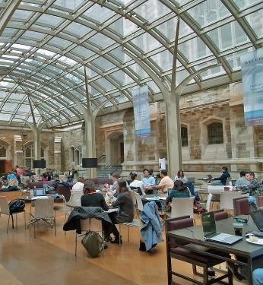
Aikens Commons
be able to serve throughout the life of the project and communicate between the project team and the requesting department (user).
As the project proceeds through design, the role of the committee diminishes and the role of the department representative increases as the focus changes from defining direction to executing the decisions of the committee. Usually, the representative attends project meetings and coordinates the department’s review of progress documents after each sub-phase of design (schematic design, design development, and construction documents).
Once construction begins, the role of the representative diminishes because the design is complete. The department’s representative may attend project meetings as the need arises, must be available to respond to unforeseen issues that often arise during construction, and must keep the requesting department informed of project progress. Toward the end of the construction phase, the representative’s role increases again as the move-in date approaches and activation activities begin.

PROJECT TEAM COORDINATION
The project team is led by the AEC project team leader. Each group provides input, guidance and professional expertise throughout the design, construction and closeout phases of the project. During the design phase, the design manager is the project team leader and is responsible for coordinating the activities of all members of the project team, keeping the project on budget, and maintaining the project schedule throughout the planning and design phases so that construction starts on the required date. The design manager acts as the university’s representative to all outside firms, directing the services performed by architects and consultants. The design manager also coordinates the requirements of the U-M design standards and the input of the various departments providing project support, and resolves conflicts that sometimes arise among them or between them and project objectives. For projects with large or complex mechanical and electrical systems, additional supporting design managers, typically from AEC’s commissioning group, are assigned to manage those specific areas of the project.
It is the responsibility of the design manager to ensure that all stakeholders are appropriately informed of issues that affect them throughout the design phase. Because two-way communication is essential for a successful project, the
design manager must be involved in every communication to properly coordinate all aspects of the project and to make the best use of the university’s resources.
A project manager who will lead the project in the construction phase is also assigned during the design phase to contribute important input regarding the budget and schedule and construction issues that need to be incorporated into the design process. As the project reaches the bid phase, the project manager will take the lead for the project, and the design manager will assist in addressing design issues through project completion.

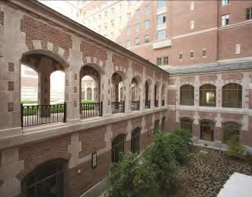
North Quad Residential and Academic Complex

TYPICAL PROJECT TEAM

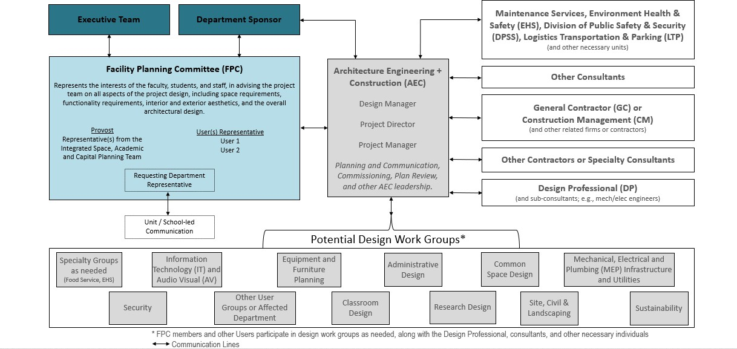

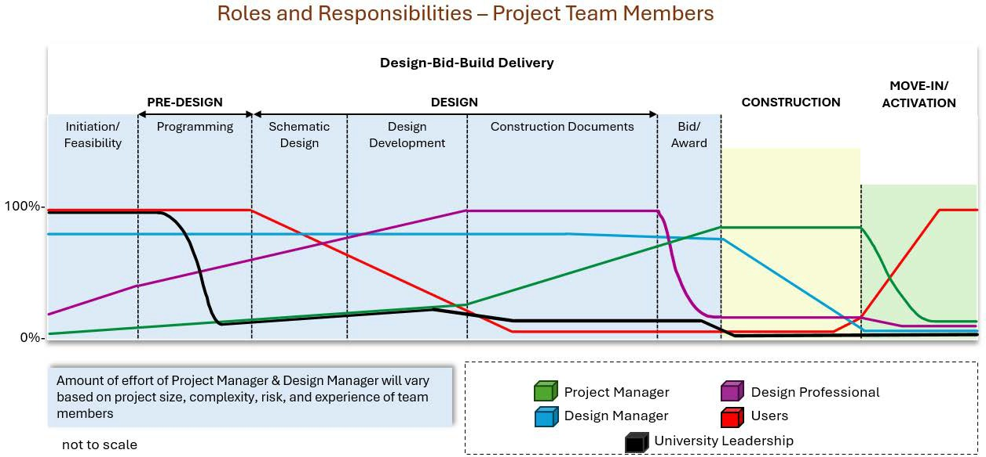

During construction, the project manager’s focus is now associated with construction administration but remains similar in regard to quality, schedule, budget, and communication. Typically, the bid process occurs at completion of design. Depending on the project delivery system chosen, the bid process may overlap design and therefore affect the responsibilities of the design manager and project manager during this overlapping phase.

EXECUTIVE TEAM
Executive teams are used only on the most complex major projects. They are intended to expedite project decision-making processes and reinforce the roles of the project team members in ensuring that the university’s resources are used effectively; that the project meets its program, cost, and schedule goals; and that conflicts between the goals are resolved expeditiously. The executive team is led by the Assistant Vice President (AVP) for AEC and includes the project director (or project and design manager, as defined by the project organization), the Provost, the Executive Vice President and Chief Financial Officer, the Vice President for Facilities and Operations, the sponsor of the requesting department, and representatives of other departments as appropriate.

DECISION-MAKING PROCESSES
Each stakeholder represents a particular interest. The requesting department has an interest in securing the facilities it needs to accomplish its mission, while the funding authority is the steward of financial resources that are subject to many competing demands. AEC must execute the project according to established parameters. However, U-M is the owner of all campus facilities, and the best interests of the university are ultimately determined by the president and the Regents. Most decisions made by the project team are the result of consensus among the various parties. When a consensus decision cannot be made, however, the issue is referred to as the next level of authority above the representatives on the project team. For the largest major projects, the matter will be referred to the executive team, while for other major projects, the AVP for AEC will attempt to resolve the matter with the university leadership or the provost and the sponsor of the requesting department. Where there is no executive team, if important enough, it may be referred to the president, who will balance goals, needs, resources, and constraints to determine the overall best course for the university.

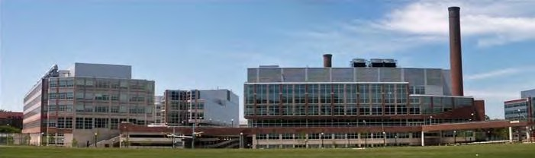
Life Sciences Institute / Palmer Drive Development

Capital Projects Approval Process

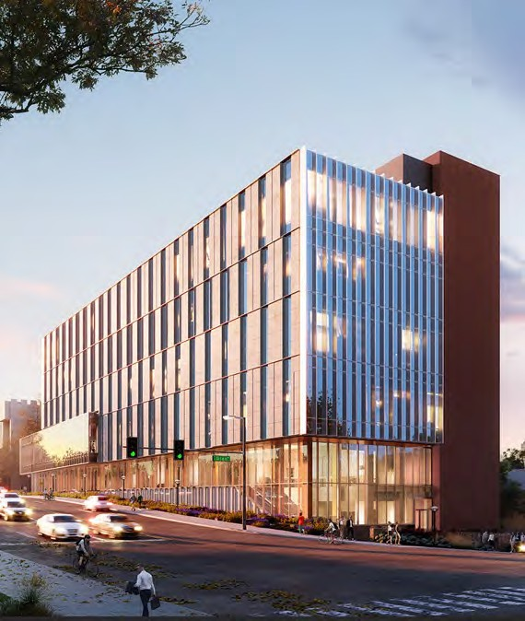
PROJECT APPROVAL PROCESS
College of Pharmacy
In general, all construction projects over $5 million require endorsement by the university’s Capital Council and approval by the Regents. For projects under $5M, the process varies depending on the university units requesting the project.
For departments within the Office of the Provost, the process is detailed in the Office of the Provost Capital Planning website.

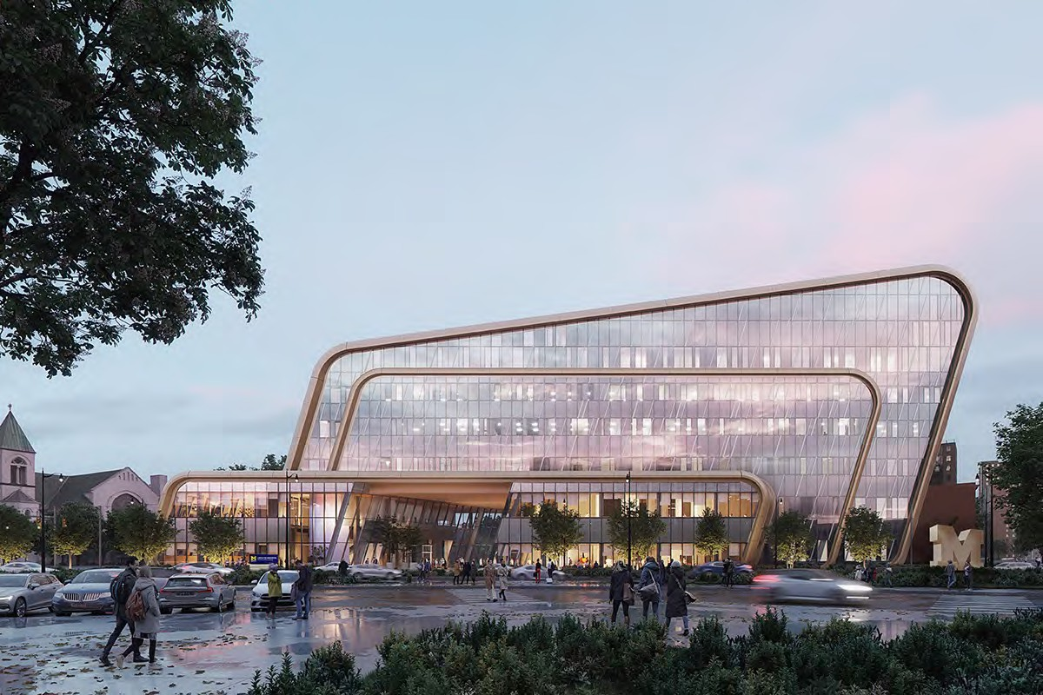
Center for Innovation (UMCI)

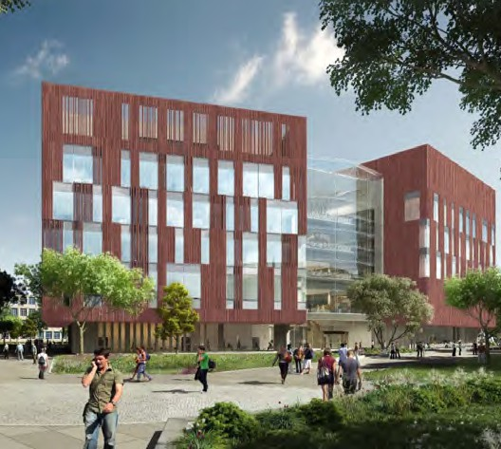
BOARD OF REGENTS
Biological Sciences Building
It is the Regents’ policy that all new construction and renovation projects that exceed $5 million shall be submitted to the Regents for approval, except in emergency situations. A status report is prepared for all projects approved by the Regents and is submitted each month a Regents meeting is held. In addition, supplemental reports for new projects and completed projects are produced for projects with budgets between $500,000 and $5M. In addition, per historical practice or university procurement policy, furnishings, environmental, and equipment purchases do not require the Regents’ approval regardless of total cost. AEC reports on projects managed by AEC only.

METHODS OF SUBMITTAL TO BOARD OF REGENTS
Major projects are typically submitted to the Regents in two separate steps:
- Approval of Project and Authorization to Appoint an Architect: Projects are presented to the Regents for approval of project. At this time, the Regents are also asked to appoint an architect (design professional) for the project.
- Approval of Schematic Design and Authorization to Proceed with Construction: In addition to meetings with users and sponsors, a meeting may be held to present the project to university leadership before schematic design approval is requested from the Regents. The design professional presents the projects to the Regents.
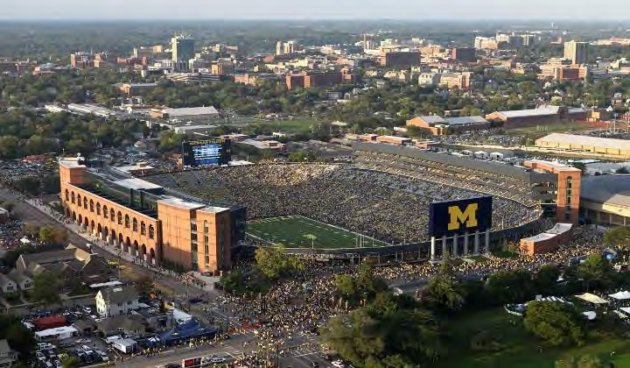
South and Central Campuses

In addition to design approval, the Regents are asked to approve proceeding with construction providing the bids are within the approved budget.
Midsize projects that are infrastructure, simple renovations, land improvement, or lab upgrades, are typically presented to the Regents one time to request Approval to Proceed with the Project for all phases including bid and award.

Project Delivery Methods

PROJECT DELIVERY METHODS
The AEC team utilizes a variety of project delivery methods to complete projects efficiently and cost-effectively while meeting user expectations for quality and aligning with the University’s goals of maintainability, energy efficiency, carbon neutrality, and overall sustainability.
All projects employ an integrated design approach. Many also incorporate a design-assist strategy, engaging specialty contractors early to enhance constructability, cost control, and technical input.
Typical Delivery Methods:
- Design–Bid–Build
- Construction Manager (CM) Delivery with Fast-Track Sequencing
- Phased Delivery with Multi-Prime Contracting
- Bridging Design–Build
- Design–Build
- Job Order Contracting (for Small CM Projects)
- In-house Construction Services
- Turnkey Delivery

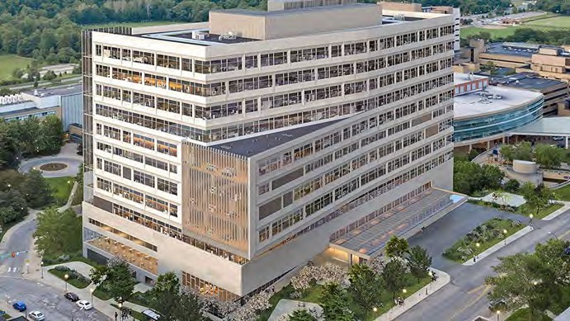
Clinical Inpatient Tower

Delivery Methods Reviewed but Not Currently Utilized
at U-M AEC:
- Progressive Design–Build
- Integrated Project Delivery (IPD)
- Public–Private Partnership (P3)
- Build–Operate–Transfer (BOT)
- Construction Manager as Agent (CMA)

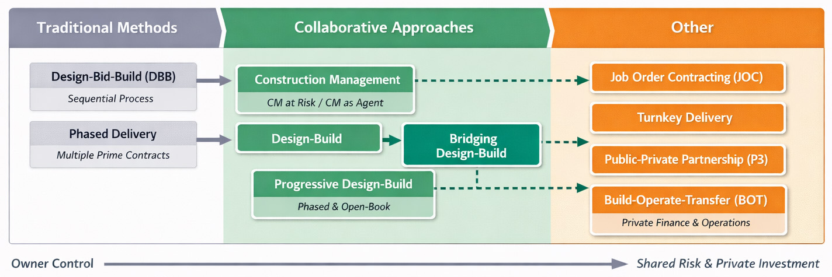

Design Professional Selection

A selection process based on qualifications is used to identify the most appropriate design professional for each project. The prime design professional must be an experienced architecture or engineering firm licensed to practice in the state of Michigan. For most projects, the design professional will be an architectural firm. The type of services provided and the phase during which the firm’s services are retained depend upon the size and complexity of the project.

MAJOR PROJECTS
For major projects, the design professional provides comprehensive services, including structural, mechanical, and electrical engineering, and is normally selected and retained during the pre-design phase through a full selection process. The services of the same design professional are usually retained for the design phase, or it may be deemed in the project’s best interest to retain the services of a different design professional. The process for major projects includes the following steps:
Identification of Candidate Firms: The project lead prepares a list of consultant firms in consultation with a selection committee that includes representatives of the requesting department, AEC, and F&O. Criteria for placing a firm on the initial list of candidates include:
- Professional reputation
- Experience with comparable projects
- Demonstrated success in working with institutions comparable to U-M
- Quality of previous work on campus (if applicable)
- Size of the firm relative to the scope of the project
Request for Proposal (RFP): The RFP contains a project description including background information, building program, design goals and objectives, construction budget, project schedule, and selection criteria. Prospective firms are asked to submit proposals describing how they communicate, analyze programs, and design solutions. Their approach to the project is of greatest interest, including their management plan, task schedule, and ability to deliver the project scope within the described budget and schedule. Observations about the project are appropriate, but proposed design solutions are discouraged.
Taubman Biomedical Science Research Building

Interview: Based on a review of the proposals, finalists (usually 3 firms) are invited to an interview with the selection committee. The focus of interviews is on each firm’s approach, process, and design solutions to other similar projects. Use of schematic designs and models for the particular project are not appropriate at the RFP stage.
Recommendation: After interviews are completed, the firms are evaluated according to specific criteria. The goal is to reach consensus and to recommend an architect to the AVP for AEC. Major projects where the scope is primarily renovation, infrastructure or utilities may be designed in-house by AEC, without a selection process.

MIDSIZE PROJECTS
For midsize projects the process is streamlined to reflect reduced size and complexity. The candidate firms generally have a history at U-M and the process begins with a review of qualifications on file. In most cases interviews are not required and the recommendation is based upon their track record, approach to the project, and ability to provide services within the required budget and schedule. If the scope of the project is primarily renovation, infrastructure or utilities, the project may be designed in-house by AEC.

SMALL PROJECTS
Most small projects, except U-M Health projects, are designed in-house (AEC A&E). If, due to workload, additional support is needed, a design professional may be selected by AEC from the established design professional departmental contracts, or from a selection process similar to that described for midsized projects. For U-M Health projects, a design professional is selected for all small projects.
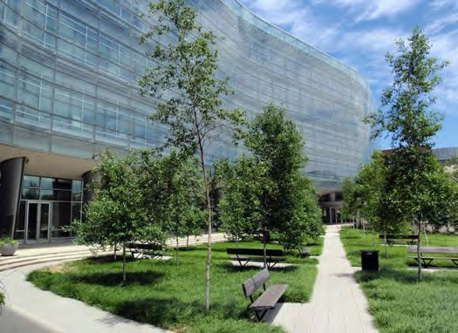
Construction on small projects may be performed through outside contractors or through the in-house construction delivery group, AEC Construction Services.

Initiation and Pre-Design Phase

The initiation and pre-design phases are the most important phases of the project. In these phases, the project team has the greatest opportunity to develop an efficient and cost-effective approach to the project. A thorough understanding and review of the goals by the sponsor, facilities planning committee, and all affected users, as well as communication with other stakeholders, will provide a design that meets all goals and will eliminate potential costly revisions during the design and construction phases which may affect overall budget, schedule and quality.
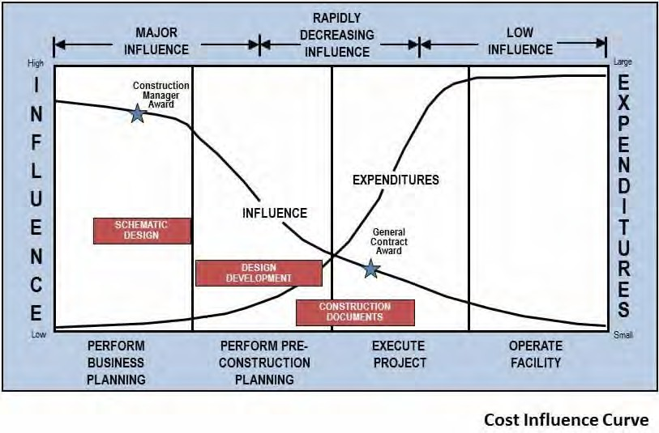

INITIATION
Initiation begins when the requesting department articulates a need for new or renovated facilities and identifies a potential funding source. During the initiation phase, the capital project approval process is followed. Pre-programming efforts may be performed by AEC to develop a placeholder budget, normally in the form of a budget range. As the project moves into the pre-design phase, a preliminary estimate, schedules, and project goals are identified, including related projects (relocation of affected group, increasing capacity of utility lines, etc.).
The amount of time required to complete the above phases can vary greatly, depending on leadership direction regarding priorities within the capital plan.

DESIGN REVIEW COMMITTEE
The Design Review Committee, composed of U-M faculty, staff and alumni, helps the university strengthen campus potential by providing input on the design of new buildings, major additions and landscape projects on all Ann Arbor campuses, including U-M Health.

PRE-DESIGN
The primary goal of the pre-design phase is to define the specific scope of the project while balancing the competing objectives of quality, cost, sustainability, and schedule. With the appropriate scope defined, the project budget and schedule can be determined.

PRE-DESIGN SUB-PHASES
In the pre-design phase, there are two sub-phases: programming and concept design.

Programming: This phase typically evaluates the user’s statement of need, and a project description is prepared, that includes the project scope and facility and system impacts in architectural and engineering terms. In this phase for renovation projects, the facility condition analysis (FCA), which is a list identifying and prioritizing capital repair items for the building, is consulted to determine what improvements to existing conditions would be appropriate to include in the project. The program, which may include several options, is then presented to the requesting department and funding authority for selection of a preferred option to be developed during the concept design phase. A placeholder budget will be established during this sub-phase.

Concept Design: During the concept design sub-phase, the preferred program option approved by the project sponsor and facility planning committee is further developed. This sub-phase confirms that the project meets the user’s needs as well as the university’s needs and budget parameters. The project team reconfirms the program identified in the earlier sub-phase and develops a detailed conceptual design and massing, a cost estimate, and a proposed schedule. Upon approval, the programming estimate is incorporated into an updated project budget.
For projects over $5M, the scope and budget are defined, documented and agreed upon by the facility planning committee. Capital Council must endorse the project before design may continue onto the next phase, unless the project falls in the excluded category covered in the Capital Council site.

BUDGET DEVELOPMENT AND CONTROL
During project initiation, a placeholder budget is developed based upon the defined scope, expected quality levels, and anticipated schedule. Construction costs are established based on benchmarking data that evaluates U-M experience with similar projects, as well as construction costs for similar projects at other universities or private entities.

At the end of the pre-design phase, the program estimate is compared with the placeholder budget. If the program estimate exceeds the placeholder budget, either the scope is adjusted or the project is approved to proceed using a higher budget, or some combination thereof. Increases must be justified. Once the final project budget is established at the end of the pre-design phase and the project is approved by the Regents, further increases in scope and budget are typically not permitted.

SCOPE DEVELOPMENT AND CONTROL
The pre-design phase is the time during which large parameter project scope is defined. Primary controls on scope are the project goals and placeholder estimates. Scope increases beyond these expectations require justification to and approval of the sponsor and, if applicable, the project executive team and/or the Provost’s Office.

SCHEDULE DEVELOPMENT AND CONTROLS
One of the purposes of the pre-design phase is to eliminate major uncertainties, which sometimes result in the discovery of complicating factors not detected during initiation of the project. In such cases additional iterations may be required before acceptable solutions are developed. However, the design manager is responsible for maintaining schedules developed at the beginning of the pre-design phase to the greatest extent possible. Schedule reviews should be a part of every project meeting to ensure that unnecessary delays are avoided.

DELIVERABLES AND REVIEW
The project form and programming report are the deliverables from the pre-design phase. The deliverables are reviewed by the user and other stakeholders, and if the project is approved in accordance with the approval process detailed herein, it moves into the design phase.

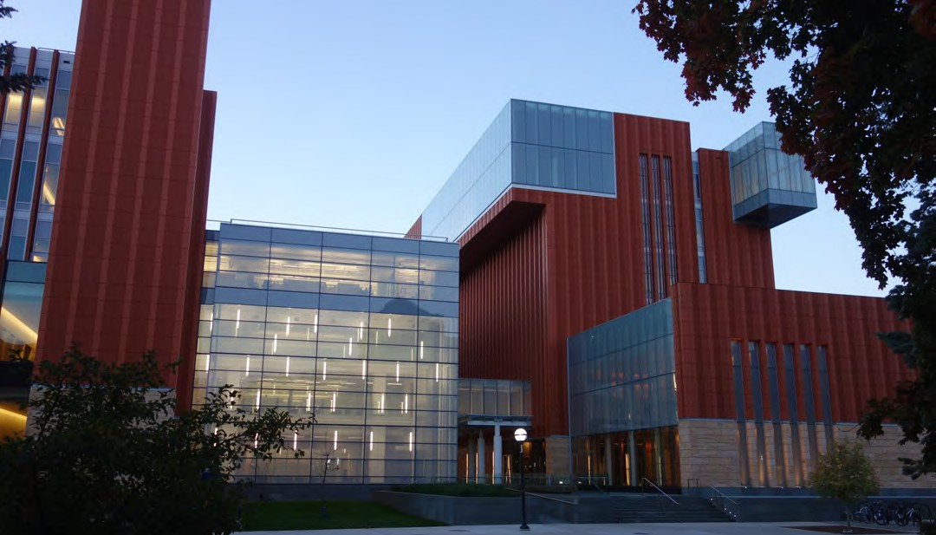
Ross School of Business and Jeff T. Blau Hall

Budgets and Estimates

Predicting and controlling costs begins with a highly informed process for budget formation in the early planning stages of the project. Project budgets evolve over time and solidify as the design progresses. It is imperative that all elements of the budget are clearly defined, captured, and developed throughout each phase. AEC uses a process involving benchmarking and cost estimating to inform and develop the project budget.

BENCHMARKING
During project initiation, the Design Manager develops a placeholder budget before a Design Professional (DP) is hired and any design work begins. The placeholder budget is based on project type, estimated gross square feet, schedule, and expected quality level. After the DP is hired and the Pre-Design effort is completed, the DP benchmarks the project against at least three similar projects. Costs are established based on benchmarking data that evaluates U-M experience with similar projects, as well as construction costs for similar projects at other universities or private entities. The placeholder project budget may be further refined at the end of Pre-Design based on the benchmarking data.

COST ESTIMATES
During the design phase, major projects go through several stages of cost estimating. The Design Professional prepares construction cost estimates at Schematic Design (SD), Design Development (DD), and Construction Documents (CD). An additional third-party cost estimate is prepared at the end of the CD phase by a separate estimating firm to confirm the Design Professional’s estimates. If a Construction Manager (CM) is added to the project team, the CM also produces a construction estimate during each sub phase of the design.
During the course of design, decisions are made on a frequent basis with the goal of achieving desired project objectives at the lowest cost. In addition, to maximize project value, at each major phase of design the project team pauses to engage in a systematic analysis of systems, materials, and equipment. Known as Value Engineering, the purpose of this analysis is to achieve prescribed functions at the lowest lifecycle cost consistent with required performance, reliability, quality, and safety. Value Engineering begins with a review of the Design Professional’s cost estimate for accuracy and thoroughness. Project costs are then examined both in total and by building system to ensure that the best possible value is being added by each group of construction expenditures.
System improvement and cost reduction recommendations are developed and compared to the base design. These recommendations, when accepted by the project team, are incorporated into the project to bring the project into alignment with established goals and cost objectives.
Value Engineering is completed and cost estimates are reconciled at each phase. If the reconciled estimate is higher than the budget, an adjustment to scope and redesign may be required. When all necessary redesign or adjustments are completed and the project is within budget, bids are solicited from contractors. Once the final project budget is established and the project is approved by the Regents, further increases in scope and budget are typically not permitted.

TYPICAL COMPONENTS OF A PROJECT BUDGET
The total project budget includes all of the items required to complete the project. Budget line items vary depending on the size and complexity of the project, and some budget items are required while others are optional. A project budget is typically comprised of the following items:
Typically included:
- Construction costs include the construction contract, materials, labor, fixed equipment, and contractor overhead.
- Related construction costs are associated with project implementation and support such as site work, utility work, environmental remediation, landscaping, signage, road and sidewalk closures, and state and city fees.
- Contingencies help plan for the unexpected and are determined by the phase of the project and the amount of risk that needs to be managed. Contingencies may vary between 5% and 20% of the project budget, depending on definition of the project at time of budget, delivery method and requested contingency for user delivery method and requested contingency for user changes. construction drawings.

A construction contingency may be used to fund a change in market conditions, unexpected conditions encountered in the field, or for errors and omissions on construction drawings.
Professional fees are included for the Design Professional, engineers and consultants, commissioning, and AEC project management.
Optional (items that may or may not be included in the project budget, may have a separate budget, or be done by the User):
  - Telecommunications costs associated with design and installation of telephone, data, and cable networks.
  - Furniture and furnishings.
  - User-managed activities such as interior signage or moveable equipment.
  - The User may also elect to include a contingency for User-managed scope changes either during the design or construction phase.
Throughout construction, the Project Manager provides budget updates to the User as part of regular construction progress meetings. In addition, budget data is available to project teams through the AEC Client Project Information site.

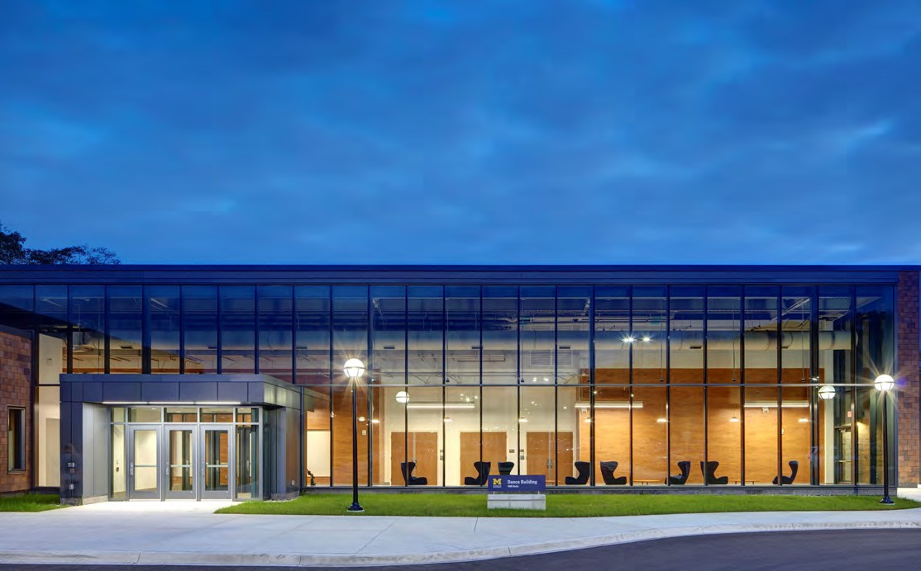
Dance Building

Design Phase

GOALS
The final goal of the design phase is to produce construction drawings and specifications to communicate to the construction team the specific nature of the project to be built that meets the user and the university’s needs. These design documents will form the basis of a legal agreement with a building contractor to build the project described in the documents for a defined price and within a defined time. The primary goal of the design phase is to translate the project definition from the program and concept design into detailed construction documents that can be used by a contractor to construct the project. Design includes the following major goals:
- Design an aesthetically pleasing facility that also efficiently meets programmatic requirements.
- Flexible design to accommodate future needs.
- Comply with building and fire codes.
- Design a facility that conserves energy and improves
U-M’s environmental sustainability.
- Address U-M requirements for design and maintenance of each building system.
- Develop details that are constructible and effective.
- Specify materials, finishes, products, furnishings and equipment that are of appropriate quality and durability for the intended use.
- Coordinate the physical elements of the project.
- Determine phasing and sequencing requirements.
- Maximize the value and minimize the cost of the project.
- Maintain the project schedule and budget throughout the design phase so that the construction phase begins on time and for the approved budget.

SUB-PHASES
Each of the design sub-phases listed below concludes with a formal document review by the requesting department, AEC, and appropriate support departments. The design professional
and third-party estimator (depending on project delivery method) prepare cost estimates which are reconciled, and a value management exercise is conducted to control the life-cycle costs of the project. Finally, stakeholder approval is sought before proceeding further.
Schematic Design (SD): During this sub-phase, the design professional reviews the pre-design deliverables and develops proposed solutions to the design problems. Existing conditions are investigated and code requirements are analyzed. Working from the conceptual design and massing developed during pre-design, the architect prepares preliminary plans, models, and proposals for exterior materials. Systems descriptions and design criteria are developed for all major building systems including mechanical systems. On projects where a construction manager (CM) is utilized, the CM provides advice on constructability, cost, and scheduling.
Design Development (DD): In this sub-phase the design professional further develops the design decisions made during the SD sub-phase and refines all aspects of the design. Upon conclusion of DD, all building systems are known and coordinated with each other. By completion of this sub-phase, the design should be developed to the point that no questions remain regarding scope, program, relationships, form, size, and appearance. Preliminary detailing and coordination demonstrate the feasibility of the design solutions. The DD sub-phase is the last opportunity for input regarding fundamental design issues.
Construction Documents (CD): In this sub-phase the design professional finalizes details to produce a comprehensive, fully coordinated set of drawings and specifications. Design changes at this point usually lead to cost increases and schedule delays. At the end of the CD phase, the architect produces a final, complete set of documents. If the project is proceeding under a phased or fast track delivery method, changes during the CD phase are highly discouraged

For projects with a budget of $10 million or greater, the user is asked to complete an evaluation at the end of the design phase. The evaluation provides the user the opportunity to provide AEC with feedback and make suggested improvements to the design phase process.

VALUE ENGINEERING
During the course of design, decisions are made on a daily basis with the goal of achieving desired project objectives at the lowest cost. In addition to this on-going value management process, at each major phase of design the project team pauses to engage in a systematic analysis of all aspects of the project. This organized analysis of systems, materials and equipment for the purpose of achieving prescribed functions at the lowest life-cycle cost consistent with required performance, reliability, quality and safety is known as value engineering.
A value engineering analysis begins with review of the design professional’s cost estimate for accuracy and thoroughness. Project costs are then examined both in total and by building system to ensure that the best possible value is being added by each group of construction expenditures. System improvement and cost reduction recommendations are developed and compared to the base design. These recommendations, when accepted by the project team, are incorporated into the project to bring the project into alignment with established goals and cost objectives.

SCOPE CONTROL
In a broad sense, changes from the scope defined in the pre-design phase are not permitted. After SD is completed, any scope change must be approved by stakeholders in writing. Prior to the SD phase, stakeholders authorized to approve changes will be identified.

BUDGET CONTROLS
Before being engaged for the design phase, the design professional reviews the pre-design deliverables and must agree to design the defined scope within the specified budget and schedule limits. At the conclusion of each sub-phase of design, estimates are prepared by the design professional. At each phase, adjustment to scope and redesign may be required for the project to remain within budget. An additional estimate is prepared at the end of the CD by a separate estimating firm to confirm the design professional’s estimate. If the reconciled estimate is higher than the budget, adjustments in scope or budget will be required prior to providing the documents to contractors for bidding purposes.
When all necessary redesign or adjustments are completed and the project is within budget, bids are solicited from contractors. If the bids result in a project cost that exceeds the budget, further adjustments to the design and a re-bid
may be required. In addition, to protect the budget and schedule, bid alternates in the amount of 5% of the construction cost must be identified by the project team and incorporated into the bid documents. These alternates are scope items, identified separately in the bid documents so that the contractor can provide a separate price for the specified work. The project team should start the process to identify these alternates with the Users early in the SD phase and review them at the conclusion of each subsequent phase. Bid alternates shall be derived in cooperation with and shall be accepted by the Users prior to bidding. At the completion of CD, the project team will have identified and approved the final list of items to be bid as alternates. If the bids are not within budget, some or all of the scope identified within the bid protection alternates may be eliminated from the project.
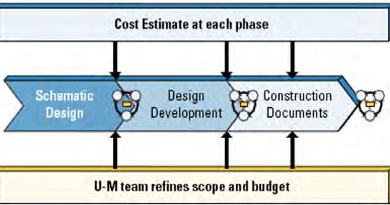

If a major project is proceeding on a phased or fast-track delivery approach, usually a construction manager (CM) is added to the project team, and the CM also produces a construction estimate during the design phase and at each sub
-phase of the design. A 15% construction contingency is required for projects that are using the fast-track delivery method. The design professional and CM are required to reconcile the estimates and produce a final estimate to be used to proceed with the project. The phased/fast-track delivery method requires that decisions are made early in design. Construction begins at the end of design development, and therefore changes are highly discouraged. In addition, since redesign is not an option with this delivery method, an additional 5% of work scope must be identified by the project team early in the design phase and carried through construction documents, and which may be removed from the project in the event that the bids are not within budget.

SCHEDULE CONTROLS
Controlling the schedule during the design phase is critical for delivering the project as promised. It is very difficult to make up for lost time during the construction phase, and construction activities are often weather-sensitive or constrained by the academic calendar. Design schedules must be established at the beginning of the design phase, taking into account the time needed for end-of-phase reviews, cost estimate reconciliations, value engineering, and redesign if necessary. Comparing progress against the design schedule must always be discussed in every regular progress meeting.
The design schedule is of utmost importance in a phased/fast-track delivery approach, as any delay in the delivery of the design documents will mutually affect the overall budget and schedule of the project.

DELIVERABLES AND REVIEW
The primary deliverables of the design phase are the drawings and specifications that form the basis of the construction contract. If the project is approved in accordance with the approval process detailed herein, it moves into the construction phase. At the end of each phase of the design process, a complete review takes place by all members of the project team. This review is especially important to the users of the project because it is the opportunity to verify that the designers have properly addressed all of their interests. For that reason, it is important that users spend the time checking the documents for conformance with their program requirements. The finalized contract documents constitute the final agreed upon scope of the project. For users that may not have experience with drawings and specifications, arrangements can be made by the design manager to assist the review.

ENERGY CONSERVATION AND SUSTAINABILITY
The University of Michigan has a long history of environmental stewardship in its approach to facility design and construction. Incorporating energy reduction in building design is one of the most effective ways for U-M to reduce its carbon footprint as the university continues to work toward reducing greenhouse gas emissions.
The university requires the incorporation of numerous mandatory energy conservation measures on projects as well as comprehensive modeling of energy usage for proposed projects and development of energy impact statements at each phase of design. All new buildings and additions with an estimated construction budget greater than $10 million are designed to achieve a minimum of Leadership in Energy and Environmental Design (LEED) Silver certification level.
The university also formally incorporated in the Design Guidelines maximum carbon emissions targets across different building types for all new construction projects as well as major renovation projects with a construction budget of $10 million or greater. These targets further enhance our goals and support U-M’s commitment to achieving net-zero emissions.
U-M’s design guidelines outline detailed requirements related to energy efficiency and environmental stewardship including energy and water conservation, sustainable design, and a sustainable products portfolio. At the end of each design phase, the project’s sustainable features are reviewed to evaluate compliance with university goals and requirements. Some examples of the university’s sustainable design and construction strategies include:
- Low-flow fixtures and sensor faucets to help conserve water
- Occupancy sensors to control lighting and reduce energy consumption
- Regionally manufactured and extracted building materials containing recycled content
- Low-e insulated glass to minimize heat gain and provide natural light
- Native and adaptive plants and efficient irrigation systems that help reduce water consumption
Additional information about AEC’s environmental stewardship efforts are available in the sustainability section of our website.

Construction Phase

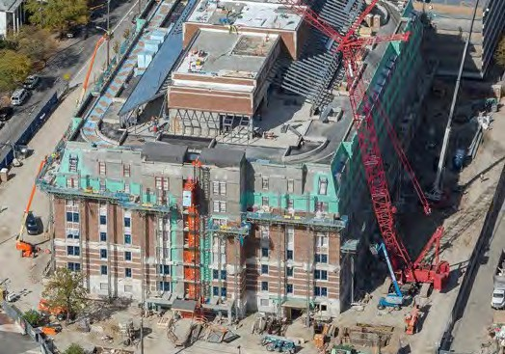
GOALS
Munger Graduate Residences

The primary goal of the construction phase is when the goals identified during the planning and design phases are implemented and the project is transformed from paper to the finished product.

CONSTRUCTION SUB-PHASES
The construction phase consists of several sub-phases that start with the procurement of construction work and end with occupancy. The sub-phases include bid and award, construction, substantial completion, and turnover.
As the project enters the construction phase, the project manager that was assigned during the design phase assumes the lead role for construction administration and becomes the primary contact for the user. The project manager’s focus includes addressing safety, change management, quality control, budget and schedule. If a project director is also assigned to the project, they provide leadership to the project team, including the design manager and the project manager, and have ultimate responsibility for total project delivery.

BID AND AWARD
The primary objective of the bid and award phase is to procure the construction work required to complete the project per the construction documents. The design professional documents are used as the basis for contractors to bid on the project.
The university follows a detailed and comprehensive process in procuring construction services to ensure that the university is getting the best value and that the contractor performing the work is suitably qualified. The evaluation and selection of construction contractors is an important part of the process. Bidders are selected from a list of U-M pre-qualified contractors. After the bids are received and evaluated, the lowest qualified bidder is awarded the construction contract.
The design manager in conjunction with the project manager performs a final review of the construction documents and works with Project Controls to assemble a bid package in order to solicit bids from multiple contractors. AEC primarily utilizes the general contractor method to deliver the construction phase of the project. With this method, the

project is completely designed and bid at one time. Other project delivery and contracting methods may be used and will follow a slightly different process. Refer to the Project Delivery Methods section (page 12) above for more information.
Contractor Qualification: The university has a thorough pre
-qualification process for contractors who desire to perform work for the university. Any contractor can apply for pre-qualification to bid on U-M construction projects. Contractors who successfully complete the application process and meet the requirements in terms of safety, bonding and experience are added to the list of U-M qualified contractors. Taking into account the overall project schedule, size and complexity, prospective bidders are selected from the list of pre-qualified contractors and invited to bid on the project.
Bid Package: An electronic bid package, called a project manual, is created consisting of a description of the work being bid, the bid due date, the university’s general conditions and construction safety requirements, and the required form of proposal. The bid package may include alternate scope items that were identified by the project team and for which the contractors will be asked to provide a separate price for the work specified.
After the bid package is created, an invitation to bid is electronically sent to the selected bidders, to authorized industry plan rooms and posted to the AEC website. Bidders obtain the project manual and the construction drawings and specifications for use in preparing their proposals.

Depending on the scope and complexity of the project, a pre-bid meeting, conducted by the project manager, may be held for the benefit of interested bidders to ask questions about the project and to ensure that all bidders understand the project scope. A site visit may be included for bidders to see the proposed project area and existing conditions. If necessary, an addendum to the original bid package may be issued to clarify or revise information contained in the university’s original bid documents.
Bid-Opening and Evaluation: In order for the bid to be accepted by U-M Procurement Services, bidders must follow the strict submittal requirements as set forth in the invitation to bid. This includes meeting the deadline set for bid submission. After the bids are received, Procurement Services staff open and review for completeness. A bid tab listing each bidder’s name and the cost of their base proposal is created. Any alternate scope items are listed and priced separately on the same bid tab. The bid tab is then shared with the bidders and the authorized plan rooms.
Contract Award: After the bids have been tabulated, they must be evaluated. For projects utilizing a general contractor, the contract is awarded to the lowest responsive bidder. After the evaluation is complete, the contractor may be invited to a formal bid clarification meeting. The purpose of the meeting is to verify and document that the bid is complete and that there are no issues with regard to drawings, specifications or schedule. If applicable, alternates may be selected at this time. An evaluation is also made of the contractors’ proposed staffing and delivery plans as well as contractor’s ability to fully commit to the project schedule.

A written Notice to Proceed (NTP) is then issued to the contractor to indicate the university’s intent to award the project and to allow the contractor to start pre-construction activities needed to meet schedule. NTP contains a request for required documents such as bonds, insurance, and a project-specific safety plan, as well as the completion date of the work and the amount of the contract. After the required documents are received, the contractor can begin work. A formal contract for construction is then executed in accordance with the NTP and based upon the construction drawings and specifications.

CONSTRUCTION
After the bids are received and the Notice to Proceed is issued, the project moves into the construction phase. The project manager is now involved in the project on a daily basis and will lead the project through to completion. On projects typically under $1M, construction may be performed by in-
house AEC Construction Services.
Some of the typical construction phase tasks and activities performed by the project manager are highlighted below.
At the start of the construction phase, the project site and all

Construction Administration Activities

led by the Project Manager

- Manage execution of construction work per contract requirements
- Monitor contractor adherence to scope, safety, schedule and budget
- Ensure design professional’s perform timely reviews of shop drawings and other submittals
- Communicate project activities and status with user
- Regular project meetings and site visits
- Overall financial adherence and reporting
- Change management-assess, evaluate and communicate impacts
- Issue resolution with contractor
- Coordinate and communicate construction impacts to university operations such as utility disruptions, sidewalk closures, etc.
- Review and approve completed work
- Coordinate required inspections and regulatory approvals
- Approve contractor payments
- Coordinate building commissioning efforts
- Coordinate temporary moves
- Coordinate furniture and equipment needs
control over activities at the site, is turned over to the contractor. The project manager is the sole university representative for all communication and direction to the contractor.
Construction usually begins with a pre-construction meeting with the project manager and the contractor. The user may also be invited to attend the meeting. The meeting serves several purposes including, but not limited to:

- Introducing project team members and defining roles and responsibilities
- Setting goals and expectations
- Reviewing project scope and management plan
- Reviewing the project schedule and identifying critical path items
- Reviewing contractual safety plan requirements

Coordination of day-to-day activities includes frequent job site visits and field inspections to ensure that the contractor is properly controlling construction activities and that work is being performed in accordance with the contract documents and university standards. Throughout the construction phase, the project manager, design professional and contractor will meet regularly to review progress, including budget and schedule.
Quality control is an important task for project managers. Even minor deficiencies can lead to increased costs and delays. While decisions regarding material specification and functional performance are decided during the design phase, quality control during the construction phase consists primarily of ensuring conformance to the contract documents. The project manager ensures that testing agencies and the design professional representative monitor the contractor’s performance by examining ongoing and completed work.

SAFETY
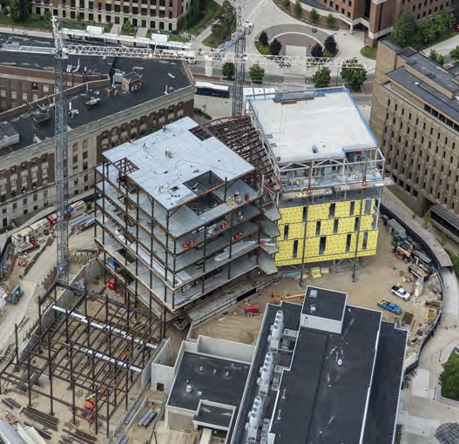
Safety is an essential component of construction work at the university and an important determinant of overall project success. The university’s goal is for zero injuries on construction projects.
Biological Sciences Building
The contractor is solely responsible for the safety of all persons and property on the job site and surrounding areas. AEC contractual requirements specify that each contractor has a safety management system in place that outlines the policies, processes, and documentation that will serve to establish the culture of safety and understanding for all involved in the project. All contractors are required to report safety orientations, safety observations, disciplinary actions and incidents. This provides an assessment of contractor safety programs on individual projects.
Safety is a team effort between AEC and U-M’s department of Environment, Health & Safety (EHS). EHS’s construction safety staff review project-specific safety plans and along with the AEC project manager ensure the contractor is adhering to the contractual requirements and enforcing their safety management plans.
Access to construction project sites is limited to those having a direct role in the execution of the project work. Visitors require pre-approval from the AVP for AEC for entry into the project site. Additional information about safety, including the university’s construction safety guidelines, are available in the Safety section of the AEC website.

COMMUNICATION
Throughout the construction phase, the project manager is responsible for communication with the contractor and the user. Regular project team meetings are held to review construction progress. The agenda for these meetings typically include a review of the schedule and budget, safety performance review and a discussion of any outstanding issues or concerns. On the most complex major projects, executive team meetings continue during construction to review progress and make decisions as needed.
In the construction phase, the user’s representative continues the role as primary contact for the project and that of representing the interests of the requesting department. It is responsibility of the user representative to keep their stakeholders informed of project progress including communicating construction activity impacts to building operations. The user’s representative will also plan for the early and proper coordination of user-managed items to avoid delays and added costs.

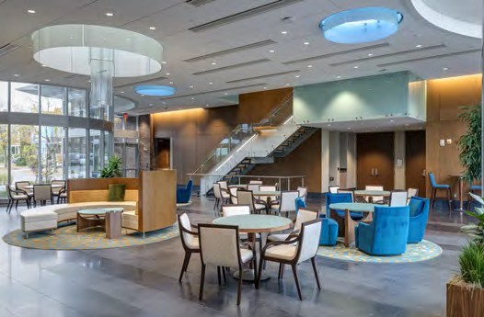
For projects $10 million and greater, the project manager issues a monthly executive summary report that details the status of the budget and schedule. Also included is the monthly safety report and a summary of construction activities for previous month’s work as well as anticipated activities for the upcoming month. AEC maintains a client web portal, called the Client Project Information site, to provide unit representatives with up-to-date information regarding their capital projects. The site is arranged by client area and provides a status report for all active projects, executive summaries for larger projects, as well as other AEC reports and presentations.
School of Nursing Building

SUBSTANTIAL COMPLETION
The project is deemed substantially complete when the work is complete in accordance with the contract documents, except for completion of minor items which do not impact the user’s ability to occupy the building. A punchlist is a document prepared during substantial completion listing minor deficiencies that need to be addressed by the contractor such as touch-up painting or damaged drywall.
Substantial completion, as determined by the design professional and project manager, initiates the warranty period for the work. Ideally, all issues identified during punchlist and commissioning activities will be resolved prior to turning the space over to the user, but some issues may take longer to resolve.

A Certificate of Occupancy (COO) is issued after the necessary inspections have taken place, including electrical, mechanical, plumbing and other building aspects. After the COO is issued, the facility is ready to be turned over to both the user and the facility maintenance groups. The warranty period typically beings once the COO is issued and generally lasts for one year. U-M maintenance groups contact the appropriate contractor from the warranty contact list for any warranty issues that may arise during the warranty period.
For projects with a budget of $10 million or greater, the user is asked to complete a construction phase evaluation at the end of the project. The evaluation provides the user the opportunity to provide feedback and make suggested improvements to the construction phase process.

BUDGET AND SCOPE CONTROLS
Cost management in the construction phase is critical to bringing the project in on budget. Changes to the scope of
the project during construction are highly discouraged because they may result in undesired cost increases and delays in the construction schedule. A construction contingency is required for each project to address unforeseen circumstances associated with the project and for potential errors and omissions in construction drawings and specifications. The amount of contingency can vary depending on the size and complexity of the project but typically up to 10% of the construction cost for new construction and up to 15% for renovation projects or projects utilizing the fast-track delivery method is provided for in the project budget.
Once in construction, the cost is fixed by contract and can only be adjusted through the change order process. A change order is a written directive to the contractor directing a change in the work within the general scope of the contract. Change orders occur for a variety of reasons including unexpected field conditions, document discrepancies known as errors and omissions and scope changes for additional work not originally planned.
- Field Condition – conditions encountered during construction that could not have been reasonably foreseen or expected during design.
- Error and Omission (E/O) – despite the best efforts of experienced design professionals, mistakes can occur. E/O changes are due to an error or omission on the part of the design professional in the construction documents.
- Code Compliance – a change resulting from an unanticipated deficiency that could not be foreseen by the Design Professional and one that is required to bring the system/building into compliance with applicable codes.

Although discouraged for the reasons noted above, users may request necessary changes in the work to address potential changes in program needs. The user may fund a separate user contingency in the project budget to pay for these requests. The amount of user contingency varies depending on the user and the overall scope of the project.
Controlling change orders and the use of contingency funds during the course of construction is critical to keeping the project within the approved budget. The project manager must document the change in a construction change directive before allowing work to proceed. The project manager assumes overall responsibility for the proper use of contingency funds as well as control of the budget through regular contingency monitoring and cost projecting.

SCHEDULE CONTROLS
Controlling the schedule during the construction phase is critical to delivering the project to the user by the agreed upon date. It is very difficult to make up for lost time, and construction activities are often weather-sensitive and/or constrained by the academic calendar. When delays do occur, we identify and examine the factors leading to the delay to determine how occurrences can be reduced or eliminated in the future.
The project manager is responsible for oversight of the construction schedule. The schedule organizes and sequences construction tasks and identifies major milestone dates that ensure the project is progressing as planned. Comparing progress against the schedule is discussed during regular team meetings and the project manager is responsible for communicating the status of the schedule to the user.

COMMISSIONING AND TRAINING
Commissioning is vital to a successful construction project. Commissioning is the process of confirming that the building’s systems and equipment is properly operating and fulfills the functional and performance requirements set forth in the design and construction documents. Allocating adequate time and resources to commissioning minimizes the risk of delays, cost overruns, and underperforming systems. The project manager is responsible for coordinating commissioning activities during the construction phase.
With today’s highly complex building systems and automated controls, a commissioning plan is essential. The plan starts in the design phase and as the construction phase nears the end, the commissioning documents are updated and executed. Building systems that are typically commissioned include
heating, ventilation and air conditioning, electrical, building envelope, and other mechanical and electrical systems as required.

As substantial completion nears, the initial start-up of systems and equipment is performed and documented followed by functional testing to assess performance prior to turnover. A final commissioning report documents the university’s

BENEFITS OF COMMISSIONING
- Overall better building performance
- Optimized energy use
- Improved building operations and maintenance documentation
- Reduced building operating costs
- Increased life-cycle of systems/equipment
acceptance of the systems and serves as confirmation that the systems were properly installed and are functioning in accordance with the original design intent. Commissioning efforts may be extended for some systems that cannot be fully evaluated during one season of the year, such as heating and cooling systems. If appropriate, these systems will go through extended performance monitoring throughout the first year.

Future effective operations of these systems and equipment require building staff to have the knowledge and resources to operate and maintain them. Prior to turnover, the user and operations and maintenance staff is provided with proper training and documentation. Training on detailed systems and equipment is provided as appropriate for the job responsibilities and typically covers features, operation, safety, maintenance and troubleshooting.

The training materials and documentation are compiled into an operations and maintenance manual and turned over to the user and to maintenance staff to facilitate proper ongoing maintenance as well as training of new staff in the future. The manual describes key components of each system and equipment and details how they should be operated and maintained for optimum performance.

TURNOVER AND ACTIVATION
Turnover of a project occurs after substantial completion of the project and the resolution of the majority of the punchlist items. Contractor record drawings, warranty information and

operations and maintenance manuals are submitted at this time. Also at this time, responsibility for maintaining the facility is also turned over to U-M maintenance groups such as Maintenance Services and Custodial and Grounds Services. For new buildings or major renovations, a Building User’s Guide is typically provided. The manual documents basic building information and key operating and maintenance features. Once the manual is turned over at the end of the project, the User assumes responsibility for the document.

To prepare for activation, the user’s representative works
with the project manager in preparation for occupancy. User
-managed tasks may include activities such as card access, signage, furniture installation, phone/data activation, and more. Early and proper coordination of user-managed items can avoid delays and extra costs. An activation checklist may be provided to assist the user’s representative in identifying and preparing for these activities.

DELIVERABLES AND REVIEW
The primary delivery of the construction phase is to deliver the facility ready for occupancy. Other deliverables include the completed construction phase evaluation and the submission of required final documents such as inspection and commissioning reports, as-built drawings, and warranty information. With user training complete, operations and maintenance manuals now reside with the user’s representative and the maintenance services groups.


James B. Angell Hall

Closeout Phase

GOALS
The goal of the closeout phase is to close the project. During this phase, the design and construction contracts are closed, the project records archived and the project financially reconciled.

ADMINISTRATIVE
The closeout phase is defined as the period between substantial completion and the point where all administrative, financial and contractual processes are complete. The length of the closeout process varies depending on the type, size, and complexity of the project. User-requested changes made after substantial completion may delay the closeout phase, and these delays can be significant depending on the number of changes. In addition, early and proper coordination of user
-managed items can avoid delays and extra costs.

The project manager must confirm all punchlist items are complete and the required documentation has been provided such as operation and maintenance manuals, warranty and commissioning documentation and as-built drawings.

The closeout phase usually does not end until the contractor’s warranty period expires, which is typically one year from the date of substantial completion. The contractor is responsible for corrective defective work during correction period. After the correction period ends, the university must prove that the contractor is responsible for defective work.
Ingalls Mall

CONTRACTOR EVALUATION
At the end of the project, AEC evaluates the contractor’s performance using criteria such as safety, quality and communication. Evaluations are also completed for projects using construction management firms to evaluate pre-construction activities and team performance. These evaluations are used to identify areas needing improvement and for consideration of future work for the university.

FINANCIAL
Financial closing can range from months for smaller projects to a year or more for larger and more complex projects.
With many projects, AEC is able to return funds at the end of the project. Unused funds are automatically returned based on the estimated final project cost once the project is six months past substantial completion, but prior to financial closeout. Early release of these unused funds allows units to use the money for other purposes.
Contracts cannot be closed until all contractors’ final pay applications have been approved and payments are issued. After financial reconciliation occurs, including all invoices are paid and any remaining unused funds are returned to the original funding sources, the project can be financially closed.

DELIVERABLES AND REVIEW
The primary deliverable of the closeout phase is the closure of all design and construction contracts and project reconciliation. Other deliverables include final payment of all invoices, the return of any unused funds and the archival of project records. After the project is reconciled a final cost report is prepared and the project is formally closed on the university’s general ledger.

Factors that Influence Project Costs

Thousands of details go into the construction of a building and costs can vary widely. In an institutional setting like ours, costs are largely driven by the complex buildings we build and the unique environment in which we build them.
U-M’s facilities reflect the values and aspirations of our institution and brand as “Leaders and Best.” Our buildings are designed for enhancing campus life, recruiting faculty and staff and creating a sense of space. In the competitive higher education sector, our buildings also play an important role in recruiting students. Some of U-M’s most iconic spaces such as the Law Quad, Museum of Art, and Ross School of Business building appear in campaign materials and in public service announcements aired on television.
Frequently, comparisons are made between institutional and commercial buildings, but many factors make this comparison very difficult. Commercial buildings are designed and built for medium traffic and short life with importance placed on financial goals. Most are built with low upfront costs and with the intention that they will be sold or fully depreciated in 20 to 30 years. Generally, institutional buildings are built to last for 75 to 100 years, are intended for heavy traffic and are typically designed with high importance placed on aesthetics, function and minimizing energy consumption and maintenance costs.
Building features and costs can vary significantly depending on program goals. Therefore, a thorough understanding of cost drivers and early goal setting among stakeholders is critical to establishing a common framework for decision-making. Following are some of the more common factors that can influence project costs here at the University of Michigan.

EXTERIOR
Building envelopes are designed to fit within U-M's rich architectural setting. Work by world-class architects feature custom designs that emphasize a sense of space. Many include monumental features that create a distinctive presence and are expressive of the building's function. For example, the curved glass at the Taubman Biomedical Science Research Building represents the innovative research taking place in the building. At the G.G. Brown Building, the giant LED light wall on the south façade has the ability to show abstract samples of active laboratory work.
Campus building façades tend to be more complex with higher-quality durable materials such as brick, stone and high
performance glass. An often-overlooked detail is the use of architectural enclosures and screen walls to hide mechanical equipment and to reduce visual clutter of rooftop or ground equipment.
In most commercial developments, there is limited, if any, need for identity or sense of space. Therefore, designs tend to be simple and inexpensive materials are often used.
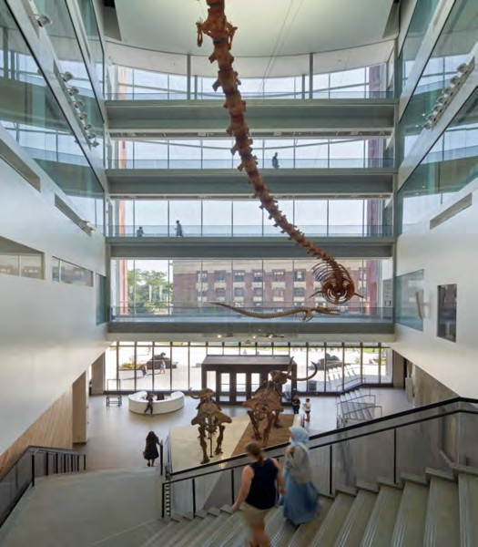
Biological Sciences Building

INTERIOR
The interior finishes of university buildings are often higher in quality for aesthetic and durability reasons. Significant use of woodwork and glass is visually appealing as are terrazzo floors and stone columns. University facilities must hold up to heavy use and therefore require durable finishes for items such as walls, doors and flooring. This creates a higher upfront cost but generally reduces maintenance and life cycle costs. Enhanced lighting and premium fixtures are often selected to fit the building's architectural context but can increase labor costs due to complex installation requirements. Varying fixture styles to meet user needs and aesthetic requirements can limit the opportunity for quantity pricing and competitive bidding.

Many building programs emphasize collaboration and community spaces to foster cross-disciplinary pursuits, encourage social interaction and hosting of large events. Atria are often desired because they create a dynamic and stimulating environment. However, these large open spaces with high ceilings require special fire and smoke management systems. Thermal control and ventilation needs can also be significant and costly challenges associated with atria space.
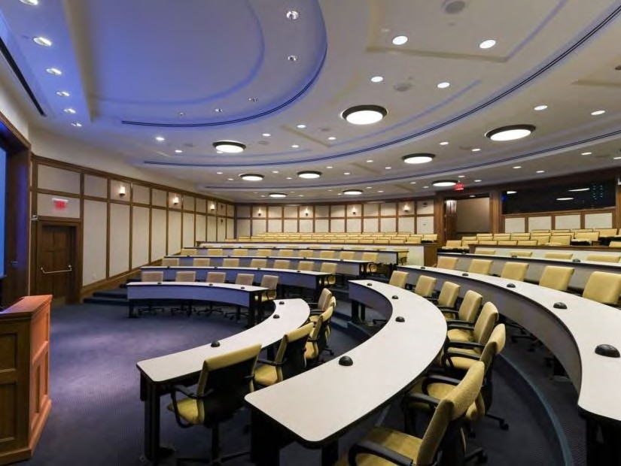
School of Nursing Building
Special requirements for classrooms include the need for increased electrical and data distribution systems, sloped floors, column-free designs, and high ceilings to accommodate technology equipment. State-of-the-art laboratories typically have complex design and construction requirements for power, ventilation and storage. Other unique building use requirements such as the need for more space to accommodate food service, bike storage and wellness rooms can cause a building to grow in size and cost.

ENGINEERED SYSTEMS
Unlike commercial buildings, institutional buildings have extensive mechanical systems to accommodate multiple building functions. Sophisticated and complex building components and monitoring systems are required to maintain consistent temperature, humidity and ventilation in sensitive environments used for teaching, research and health care. Additionally, there is often a need for system redundancies, generators and an uninterruptable power supply source. Specially designed humidification systems may be required to avoid damage to a building's high-quality millwork or to preserve rare books or artifacts.
Buildings incur costs over their lifetime; therefore, heating, ventilation and air conditioning (HVAC) units are of higher quality for increased reliability, lower energy consumption and
reduced maintenance costs. However, this typically comes with higher upfront costs. Commercial developments emphasize first costs and use basic systems that come off the shelf.

ENERGY AND SUSTAINABILITY
The university places great importance on energy utilization and incorporating sustainable elements is a priority on all projects. The university's guidelines for design and construction stipulate many sustainable measures as applicable to the project's scope and budget. For example, projects with a construction budget greater than $10 million are required to implement energy conservation measures that result in an energy performance that is better than that of a baseline building that simply meets the Energy Code. Also, new construction and addition projects with a similar budget are required to meet Leadership in Environmental Energy and Design (LEED) Silver certification.
Some examples of other sustainable strategies include:
- Comprehensive modeling of energy usage and the evaluation of energy conservation measures.
- Enhanced building envelope inspections to ensure that materials and assemblies installed are consistent with construction drawings and specifications. Larger projects often incorporate thermal scanning of the building to ensure insulation, sealant and air-barrier integrity.
- High performance glass glazing with low-e coating.
- Heating, ventilation and air conditioning zoning by occupancy type with an operations schedule and/or sensors to allow shutdown or setback during reduced occupancy.
- Construction waste material segregation and recycling.
- The use of native and adaptive plants and highly efficient irrigation systems in landscape designs.

SITE
Most U-M sites, especially on Central Campus, are very constrained by space making construction logistics (staging, laydown, materials delivery, and parking) more challenging and costly.
Extensive site preparation may be required and may include tree protection, tunnel protection and relocation of infrastructure for existing utilities. Within the City of Ann Arbor, many projects are required to pay for upgrading

or replacing of city utility lines or for incorporating stringent storm water management measures into the project.
With the density of the campus environment, it is often necessary to optimize the building footprint by building upward to conserve land. High-rise construction requires the use of tower cranes for steel erection and placement of equipment. Commercial developments are typically in suburban areas with ample land for construction logistics and can accommodate larger building footprints and low-rise construction.

SCHEDULE AND MARKET CONDITIONS
Sometimes overlooked is the impact the schedule can have on cost. Generally, there is an expectation that construction activities will be conducted with minimal disruption. Depending on the project's location and occupancy status, it may be necessary to limit noise or areas of construction operations during certain times, thereby necessitating phasing of work.
Many users desire a compressed project schedule to accommodate the academic calendar or the availability of grant or donor funding. In general, shortening the time will drive up costs due to overtime and extra shifts. A shortened
schedule may require expedited fabrication and delivery of materials and equipment, often at a cost premium.
Finally, market conditions can also influence project costs from rising commodities prices to labor rates and worker availability, especially in good economic times and with competing projects.

SUMMARY
All of these factors and more must be considered when examining project costs. While there can be significant variation in costs depending on program goals, the overriding theme at the University of Michigan is quality and longevity.
From the earliest stages of the project, the project team must work together to understand and manage expectations. At the root of this is a thoughtful and clear understanding of the project goals and the factors that influence costs.

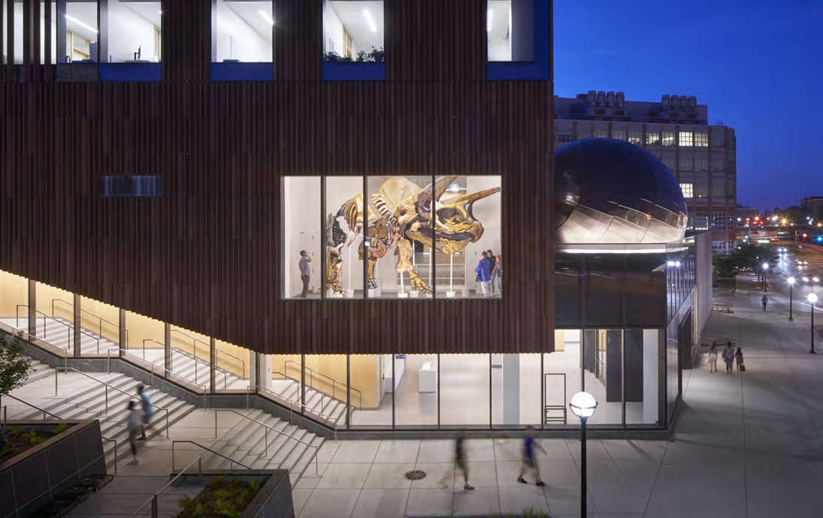
Biological Sciences Building Museum of Natural History

BUILDING COMPARISON OVERVIEW

PROGRAMS THAT CAN GROW THE UNIVERSITY BUILDING (20-30%)
  - Atria, amenity space and communicating stairs
  - Larger and more enclosed offices
  - Classrooms that require greater floor-to-floor height, larger corridors and queuing areas
  - Basement and penthouse construction for enclosed mechanical spaces
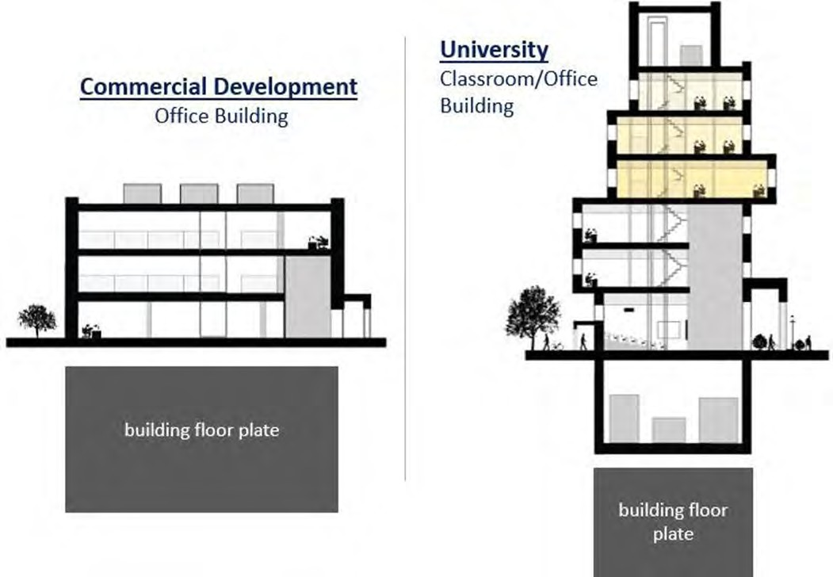

FACTORS THAT CAN INFLUENCE COST

  - Exterior: longevity, high caliber and custom design, monumental features, multiple entrances

  - Interior design: high-quality finishes and furnishings

  - Sustainability: maximized energy efficiency and incorporation of sustainable design elements

  - Exterior site enhancements: plazas, set walls, wider sidewalks, increased accessibility, extensive landscaping

  - Constrained building site: smaller floor plate, more floors, construction logistics

Definitions
AEC: The University of Michigan’s department of Architecture, Engineering and Construction is responsible for managing the design and construction activities for all assigned university capital construction projects.
Capital Council: With representation from U-M Ann Arbor, U-M Dearborn, U-M Flint, and U-M Health, oversees the impact assessment for capital projects by applying both qualitative and quantitative metrics into the delivery of all major capital initiatives.
Capital Project: A project that involves a long-term and substantial university investment to acquire, develop, improve, and/or maintain a capital asset (such as land, buildings, infrastructure, roads). Capital projects are subject to the university’s capital projects process.
Certificate of Occupancy: A document issued by the university’s Environmental Health and Safety department indicating all final inspections are complete and the building or space is ready for occupancy.
Change Order: An agreement between AEC and the vendor directing a change in work within the general scope of the contract.
Commissioning: Building commissioning provides documented confirmation that building systems function according to criteria set forth in the project documents to satisfy the owner’s operational needs. Commissioning existing systems may require developing new functional criteria to address the user’s current requirements for system performance.
Construction Change Directive: A directive from AEC to the contractor authorizing additional work.
Construction Services: An AEC department providing in-house construction services (in-house contractor, e.g.) for small projects.
Consultant: A person and/or company hired by the university to provide expertise. A consultant may or may not be a registered architect or a professional engineer.
Department Representative: Department primary contact for the project to represent all departments on the project team. Many times, this will be the facility manager.
Department Sponsor: Person that advocates for the project at initiation and throughout the capital project process to articulate project goals and control requests related to scope. Typically, this person will be the dean, chair, or director.

Design Deliverables: The set of minimum documentation required at each major phase of construction project design (defined in detail in the Design Guidelines).
Design Guidelines: The set of design guidelines that provide direction to design professionals and other consultants to assure maximum quality and value.
Design Manager: AEC design managers are responsible for administration of the project during design including addressing quality control, budget, schedule, and communication with the user.
Design Professional: The legal entity contractually entrusted by the university with the responsibility for design and/or construction administration services. Either employs or subcontracts the services of architects, engineers, planners and/or designers as required by the specifics of the project and the legal agreement with the university. On small projects, the design professional may be a designated in-house AEC staff member.
Design Standard: Generally accepted uniform procedures and/or requirements of construction components/assemblies that directly affect the design and performance of a facility. Design standards may be required by building codes and/or by university design guidelines.
Facility Planning Committee: Represents the interests of the faculty, students, and staff in advising the project team on all aspects of the project design, including space requirements, functionality requirements, interior and exterior aesthetics, and the overall architectural design.
Infrastructure: The basic, underlying framework of facilities/ systems for a building or campus.
Maintenance Services (MS) Departments: Depending on the facility, for most projects that are general fund, refer to the MS site. For U-M Health projects, refer to the Facilities Planning & Development (FP&D) site.
Major Projects: Projects with budgets of more than $10M.
Midsize Projects: Projects with budgets of $5 million to
$10M.
Notice to Proceed: A written notice from the university issued to the contractor indicating the intent to award the contract and permitting the contractor to start pre-construction activities.

Operations and Maintenance Manual: Training materials and other documentation for equipment and systems that is compiled and turned over to the user upon substantial completion.
Owner: The Regents of the University of Michigan.
Project Manual: An electronic bid package detailing the scope of work, bid due date, and other instructions and requirements.
Program: Generally developed by the user, the program is a written description of the proposed project including rationale, goals, space requirements, schedule, and funding.
Project Director: In addition to the design and project manager, a project director may be assigned to the most complex major projects to provide overall leadership during both design and construction.
Project Form: A form, generally signed by the sponsor or user, authorizing AEC to proceed with the project and to encumber funds.
Project Goals: A common framework established by stakeholders and used to evaluate future decisions.
Project Manager: AEC project managers are responsible for administration of the project during construction, addressing safety, quality control, budget, schedule, and communication with the user.
Punchlist: A document prepared during substantial completion listing minor deficiencies that need to be
addressed by the contractor to bring the work into compliance with the requirements of the construction contract.
Small Projects: Projects with budgets of less than $3 million.
Substantial Completion: the stage in the progress of the work when the work is sufficiently complete and functional, with all systems and components approved and operational, in accordance with the requirements of the contract documents. The Owner can legally use and occupy it for its intended purposes without material interference from unfinished or improperly finished items of Work and subject only to Punchlist items which do not preclude occupancy.
Turnover: occurs after Substantial Completion of the project and the resolution of a majority the punchlist items. Contractor record drawings are submitted at this time, and responsibility for maintaining the facility is also turned over to U-M maintenance groups.
University (U-M) Leadership: Includes the President, Executive Vice President and Chief Financial Officer (EVPCFO), Provost, and the Executive Vice President for Medical Affairs (EVPMA).
Users: Those who will ultimately occupy the space being created or renovated by the project.
Value Engineering: the detailed analysis of systems, equipment, materials, services, facilities, and supplies required by the contract documents for the purpose of achieving the desired and essential functions of the Owner’s program at the lowest cost consistent with required and necessary performance, longevity, reliability, quality and safety.

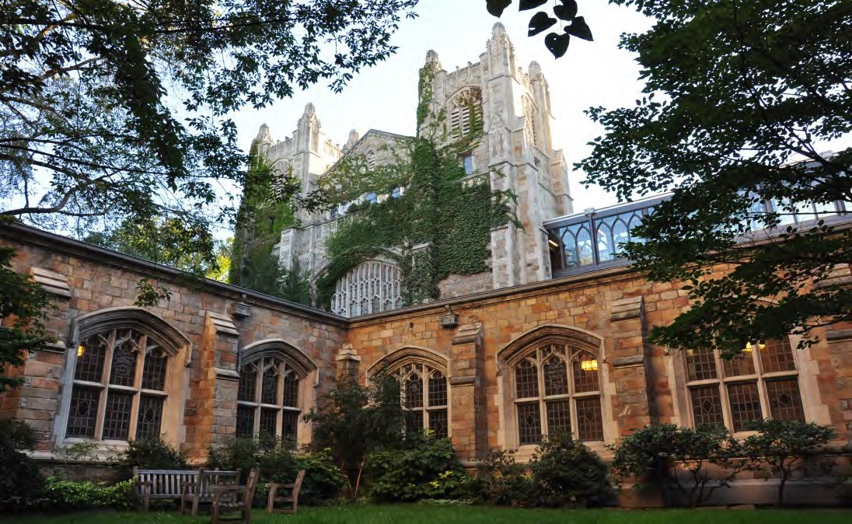
Law Quad

Appendices

Design Phase and Typical Tasks
Project Delivery Methods
Project Goals Template
User Satisfaction Evaluation
Other Reference Material:

Building User’s Guide Example
Contracts and Agreements for Professional Services
Design Deliverables
Design Guidelines
Project Estimates
Safety Program

DESIGN PHASES AND TYPICAL TASKS

(not including approval steps from U-M Leadership or Regents)

 | Phase | Sub Phase | Tasks | Deliverables
Capital Project Guidelines | Initiation  (Statement of Need) |  | Requesting department articulates a need for a capital improvement and identifies a potential funding source  Analyze space request Assess needs  Initiate a project study  Determine high-level project goals  Define general scope and options, including enabling projects Develop placeholder estimates based on comparable project costs Capital Projects approval may be required | Statement of Need and AEC Study or Project Form
Capital Project Guidelines | Pre-Design | Program (if undertaken  separately from concept design) | Design Professional selection Conduct project orientation meeting  Define project goals; occupant growth and unique character, building codes, community issues, environmental issues, historic preservation, security, etc.  Identify energy and sustainability goals Identify key site and building relationships Conduct detailed space programming  Perform evaluation of existing space  Evaluate options and identify preferred option  Establish construction costs using benchmarking data projects Confirm acceptability of preferred option with all stakeholders | Program Report and  Evaluation of Existing Space with recommended option and estimate
Capital Project Guidelines | Pre-Design | Concept Design | Develop conceptual design, with siting and massing if needed Develop general building systems descriptions  Determine contracting approach  Confirm scope, budget, and schedule with all stakeholders Initiate a new project if started as a study | Concept Design Report with estimate and project budget  AEC Project Form
 | Design Phase | Schematic Design | Hold progress meetings to develop design  Describe proposed building systems and utilities requirements Investigate existing conditions  Analyze code compliance Conduct stakeholders reviews  Cost estimate, risk analysis, and value management  Obtain approval from Regents for schematic design and authorization to proceed with construction | SD documents; Reconciled scope, estimate, project budget and schedule
 | Design Phase | Design  Development | Hold progress meetings to develop design Perform engineering load calculations  Develop major features of all building systems  Meet with code authorities for preliminary review Analyze life-cycle costs  Conduct stakeholder reviews  Cost estimate, risk analysis, and value management | Monthly project reports; DD documents; Reconciled scope, estimate, project budget and schedule
 | Design Phase | Construction Documents | Hold progress meetings to finalize design  Articulate entire design in drawings and specifications Site plan review; approvals as necessary  Coordinate all building elements Conduct technical review  Conduct final review with code authorities Develop submittal list  Identify bid alternates, allowances, unit prices Conduct stakeholder reviews  Cost estimate, risk analysis, and value management Establish bidding parameters | Monthly project reports; CD documents; Drawings and specifications;  Reconciled scope,  estimate, project budget and schedule

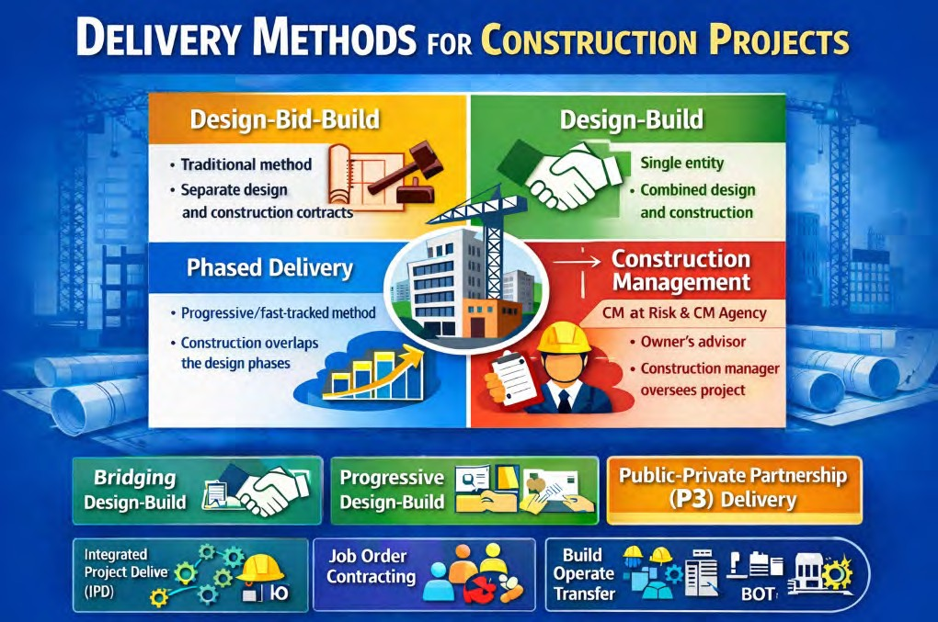
Typical Delivery Methods:

PROJECT DELIVERY METHODS

Design–Bid–Build
Process: The owner contracts separately with a designer (architect/engineer) and a builder (general contractor). The project is fully designed before bidding out to contractors and subsequently built.
Pros: Familiar process; enables competitive bidding; clear separation of design and construction; allows for comprehensive coordination of design documents; fewer design changes during construction.
Cons: Longer project duration; limited contractor design input; potential for adversarial relationships.

Construction Manager (CM) Delivery

with Fast-Track Sequencing
Process: The owner engages a Construction Manager (CM) during design to provide preconstruction services such as budgeting, scheduling, and constructability reviews. Once sufficiently designed, the CM commits to a Guaranteed Maximum Price (GMP).
Pros: Early contractor involvement; enables value engineering; encourages collaboration.
Cons: Careful timing of the GMP is critical to avoid excessive contingencies; collaboration between architect and CM may decrease if GMP is set too early; overlapping design and construction increases the risk of document coordination issues in the field.

Phased Delivery with Multi-Prime Contracting
Process: The owner contracts directly with multiple trades/subcontractors (e.g. electrical, plumbing, structural) rather than a single general contractor.
Pros: Potential cost savings; direct communication.
Cons: Owner assumes greater coordination and risk; project management is more complex.

Bridging Design–Build
Process: The owner’s architect develops partial (“bridging”) design documents (typically 30–40% complete), and the contractor’s design-build team completes the design.
Pros: Owner retains early design control; gains efficiencies of design-build.
Cons: Risk of design intent erosion; quality relies heavily on the bridging documents; items not well specified may receive lower-quality design.

Design–Build
Process: The owner issues a single contract covering both design and construction, typically via performance or prescriptive specifications. The architect may partner with, or consult to, the design-build entity.
Pros: Offers schedule and cost efficiencies; a single point of responsibility.
Cons: Owner has less design control; fewer checks and balances; midstream design changes are difficult; risk that items not clearly defined in specifications receive lower-quality design.

Job Order Contracting (for Small CM Projects)
Process: A fast-track approach used for smaller, repetitive projects. Owner and contractor agree on preset pricing, often for maintenance or upgrades.
Pros: Rapid mobilization; predictable pricing.
Cons: Less competitive; best suited to limited scope projects.

Turnkey Delivery

PROJECT DELIVERY METHODS
Process: The owner specifies requirements, and the contractor delivers a complete, ready-to-use facility, covering all aspects from design to commissioning.
Pros: Minimal owner involvement; single point of accountability; rapid delivery for standardized or specialized projects.
Cons: Limited owner control over design and quality; less flexibility for changes; outcome depends on tightly defined scope.
Delivery Methods Reviewed but Not Currently Utilized at U-M AEC:

Progressive Design–Build
Process: A collaborative design-build approach. Team selection is based on qualifications. Scope, design, and price are developed collaboratively before setting a final lump sum or GMP, following a two-phase process:
- Phase 1: Team selection and collaborative development of scope, design, and pricing.
- Phase 2: Transition to a fixed price or GMP upon agreement of project parameters.
Pros: Highly collaborative; transparent and detailed cost development; improved coordination and design quality.
Cons: Not ideal for prescriptive owners; may involve higher costs; requires additional owner personnel and financial reviews; process is non-competitive.

Integrated Project Delivery (IPD)
Process: The owner, architect, contractor, and key trade partners join under a single, multi-party contract. The team works collaboratively from early design through construction, sharing risks, rewards, and problem-solving.
Pros: Maximizes collaboration; aligns incentives; innovative approaches; effective change management; reduces disputes.
Cons: Complex contract structure; requires strong trust and communication, requires additional owner personnel and financial reviews of detailed accounting requirements; process is non-competitive and has potential for higher costs.

Public–Private Partnership (P3)
Process: The public owner partners with a private entity that finances, designs, builds, and may operate/maintain a facility. Compensation may include user fees, rent, or availability payments. Ownership typically reverts to the public entity after a set period.
Pros: Transfers initial cash flow and operational risk; can accelerate delivery if fast tracked.
Cons: Complex contracts and negotiations; long-term commitments; may reduce owner control; financing costs and development costs which increase project expenses.

Build–Operate–Transfer (BOT)
Process: The private partner designs, builds, finances, and operates a facility for a defined period, after which ownership and operation transfer to the owner. Common in infrastructure projects.
Pros: Reduces upfront public capital; leverages private sector efficiency; transfers operational risk in early years.
Cons: Long-term commitments; potentially higher overall costs due to private financing and development costs; complex regulatory/legal framework; limited owner flexibility until transfer.

Construction Manager as Agent (CMA)
Process: The owner retains a construction manager to advise and coordinate throughout design and construction. The owner
holds direct contracts with subcontractors, while the CM manages scheduling, coordination, and quality assurance.
Pros: Owner maintains contracting control; benefits from CM’s expertise.
Cons: Owner assumes financial risk for overruns and claims; requires more owner management for each individual contract;
complex coordination of multiple contracts. Limited values added by CM.

PROJECT GOALS TEMPLATE

Building Name – Project Name AEC Project #P0000####

Project Goals:

Goal setting among the critical stakeholders for a project is intended to clarify major scope issues as well as establish a common framework which can be used to evaluate future decisions. The following is a generic list of potential goal categories which may (or may not) be applicable to the project. The list is not intended to be all inclusive but rather serve as a catalyst to a discussion of project-specific goals and objectives.

Stakeholders (i.e. Facility Planning Committee membership) User program needs
Provost requirements
Special uses (special events or etc.)
Flexibility of spaces (generic vs. custom, future uses, etc.) Budget
Funding restriction/requirements (grants, capital outlay, gift agreements, etc.) Schedule (interim milestones/deadlines and overall completion)
Square footage (standards, efficiency ratio, etc.)
Site planning principles
Storm water management planning needs
Parking and transportation needs including displaced and new parking for employees, visitor, patient Sustainability (LEED, energy efficiency, etc.)
Regulatory issues (AHJD, flood plain, animal, etc.) Risk assessment (for projects >$100M)
Anticipated approach for City project review, if applicable Community engagement process, if applicable
Facility environmental requirements (HVAC, sound, vibration, etc.) Historic preservation
Deferred maintenance items (FCA, etc.) Existing building code and life safety issues Accessibility issues
Quality (level of finishes and building systems) Security and safety
Classrooms (number and type)
Special spaces-new or existing (food service, workout facilities, server rooms, etc.)
Operational considerations (total cost of ownership, reliability of systems, and maintainability during operation)
Building User's Guide
Furniture and equipment
User Satisfaction Evaluation process
Appropriate Process for Use of Documents and Images

USER SATISFACTION EVALUATION—DESIGN

AEC is committed to providing excellent customer service and in doing so, we continually look for ways to improve. We use a project-specific user satisfaction evaluation to establish clear expectations for AEC’s performance during both the design and construction phases for projects with a budget of $10 million or greater. The responses are used to identify areas of concern and enable us to improve the quality of our services. The evaluations also provide an opportunity to recognize staff for favorable performance and thank them for a job well done.

The design phase evaluation questions will be used to evaluate AEC’s performance. The questions cannot be changed, but project-specific comments or concerns may be written in the comments section or included on a separate piece of paper. Consistent with the structure of the project team, the User/Representative will represent all stakeholder input when completing the evaluation. As such, complete only one evaluation per project, per evaluation phase. At the end of the design phase, the design manager’s supervisor will ask you to evaluate AEC’s performance by completing the survey. A similar process will be followed in the construction phase and will be handled by the project manager/director.

Thank you in advance for participating in the User Satisfaction Evaluation process. Your feedback plays an important role in helping us maintain our commitment to excellence.

Design Phase Questions: | 1  Dissatisfied | 2  Somewhat Dissatisfied | 3  Neither Satisfied or Dissatisfied | 4  Satisfied | 5  Highly Satisfied | Comments
Was the ‘design process’ document reviewed
and the process clearly explained at or prior to the design kickoff meeting?
Were the design meetings organized and
productive?
Did meeting minutes accurately reflect
decisions made at design meetings?
Were the User’s ideas and input given
proper consideration given the fiscal and physical constraints of the project?
Was the overall design schedule as agreed at
the design kickoff meeting met? If the schedule slipped, were there documented reasons?
Did AEC personnel foster an environment
that made the interaction between the design professional and the user representative(s) conducive to a successful design process?
Was the project scope change process
explained and followed in an appropriate manner?
Do you believe the final design meets your
expectations considering the available resources?
Were the design team's (external architects
and/or AEC) explanations as to design choices clear and sufficient?
How pleased were you with the overall
design process?
Comments:

USER SATISFACTION EVALUATION—CONSTRUCTION

AEC is committed to providing excellent customer service and in doing so, we continually look for ways to improve. We use a project-specific user satisfaction evaluation to establish clear expectations for AEC’s performance during both the design and construction phases for projects with a budget of $10 million or greater. Responses are used to identify areas of concern and enable us to improve the quality of our services. The evaluations also provide an opportunity to recognize staff for favorable performance and thank them for a job well done.

The construction phase evaluation questions will be used to evaluate AEC’s performance. The questions cannot be changed but project-specific comments or concerns may be written in the comments section or on a separate piece of paper. At the end of the construction phase, the project manager/director’s supervisor will ask you to evaluate AEC’s performance by completing the survey.

Thank you in advance for participating in the User Satisfaction Evaluation process. Your feedback plays an important role in helping us maintain our commitment to excellence.

Construction Phase Questions: | 1  Dissatisfied | 2  Somewhat Dissatisfied | 3  Neither  Satisfied or Dissatisfied | 4  Satisfied | 5  Highly Satisfied | Comments
Was the construction process clearly explained at
or prior to the construction kickoff meeting?
Were the construction meetings organized and
productive?
Did the project team emphasize and explain the
project’s safety program?
Were questions regarding the project budget
answered adequately given the fiscal constraints
of the project
Was the project scope change process explained
and followed in an appropriate manner?
Was the construction schedule managed
appropriately including interim and final completion dates (taking into account user changes)?
Were occupancy activities such as furniture and
equipment installation IT and phone installation, and other user managed items given adequate consideration in the overall project schedule>
Were construction impacts to facility operations
(noise, dust, utility shutdowns, infection control, etc.) adequately managed by the construction team?
Did AEC personnel foster an environment that
made the interaction between the construction team and the user representatives, when needed, conducive to a successful project?
Does the final product meet your expectations in
terms of construction quality and adherence to the project design?
How pleased were you with the overall
construction process?
Comments:

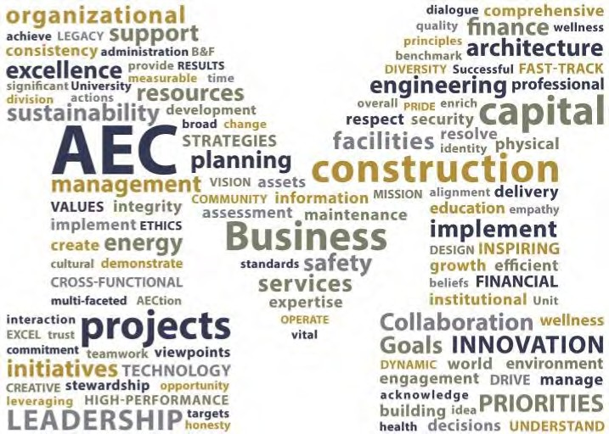

Architecture, Engineering and Construction

University of Michigan 326 East Hoover Avenue Ann Arbor, MI 48109-1002
734.763.3020
umaec.umich.edu

