
  The Regents of the University of Michigan
  Owner Controlled Insurance Program
  Insurance Manual
  [insert project name]
  Project Number: PROJECT #
  IMPORTANT: When enrolling, insert Project Number above!

Prepared by:



Table of Contents

Sections Page

Insurance Coverages .3

Program Eligibility 6

Enrollment Responsibilities Flow Chart 8

Insurance Required from Construction Manager and Trade Contractors 9

Program Reminders 12

Accident Reporting and Claims Procedures 13

Definitions 14

Personnel Directory 15

AJG/VUE Online Portal – Online Enrollment Instructions……...................................................................16

Step 1: Registering and Logging In…….…………………………………...................................................................16

Step 2: Accessing Existing Enrollment or Adding a New Enrollment…..........................................................17

Step 3: Completing the Application for Enrollment……..…...................................................................19

Step 4: Reporting Payroll Online……………………………….……...................................................................25

Step 5: Close Out………………….….……………………………….……..................................................................27

Insurance Coverages

The Regents of the University of Michigan Owner Controlled Insurance Program (OCIP) will provide the following insurance to all enrolled Trade Contractors for the [insert project name] project. [insert name] is the Construction Manager. Arthur J. Gallagher & Co. Insurance Brokers is the Insurance Broker and Insurance Administrator. Policy copies are available upon request.

Worker’s Compensation, General Liability, and Excess Liability coverage will be afforded to all enrolled parties whose employees perform actual on-site labor at the project site.

Workers’ Compensation Insurance:
Statutory limits, with Coverage B - Employer's Liability limits of:
Bodily Injury by Accident | $1,000,000 | Each Accident
Bodily Injury by Disease | $1,000,000 | Each Employee
Bodily Injury by Disease | $1,000,000 | Policy Limit

Each enrolled project will have project specific liability limits*applying to all enrolled parties jointly with the following limits:

Commercial General Liability Insurance:
$2,000,000 | Each Occurrence
$2,000,000 | Personal and Advertising Liability
$4,000,000 | General Aggregate
$4,000,000 | Products and Completed Operations Hazard Aggregate (PCOH)
$1,000,000 | Damages to Premises Rented to You
$10,000 | Medical Expense Limit

*Projects with Hard Costs equal to or greater than $50,000,000 will have project specific Products and Completed Operations Hazard Aggregate.

**Six (6) Years Completed Operations coverage from substantial completion of each enrolled project or State Statute of Repose, whichever is less.

Excess Liability Insurance:
$75,000,000 | Each Occurrence
$75,000,000 | General Aggregate
$75,000,000 | Products and Completed Operations Hazard Aggregate

General Liability Deductible / Loss Sharing Responsibility:

Construction Manager and enrolled Trade Contractors shall be responsible for the first $25,000 of any General Liability losses to the extent such loss results from the fault or neglect of a trade partner of any tier, or someone for whom either may be responsible.

Defense Costs:

Defense Costs are in addition to Limits of Liability & Limits Reinstate Annually

Evidence of Insurance:

Gallagher will issue certificates of insurance evidencing coverages provided under the project to each enrolled party. The certificate of insurance and insurance policy will include a 30- day notice of cancellation clause.

The insurance coverages do not include all insurance needed by Construction Manager and Trade Contractors. For example, Workers' Compensation and General Liability coverages apply only to the operations of and for each enrolled party at the Project Site. They do not apply to the operations of any enrolled party in their regularly established main or branch office, factory, warehouse, or similar place. Independent Truckers/Haulers will not be enrolled under the Program.

OCIP Program Term:

April 22, 2026 to April 22, 2031 and six (6) Years Completed Operations coverage from substantial completion or State Statute of Repose of each enrolled project, whichever is less.

Insurance Carriers:

- Commercial General Liability Insurance: Liberty Mutual Insurance Company
- Workers Compensation Insurance: Liberty Mutual Fire Insurance Company
- Excess Liability Insurance (1st layer): Ohio Casualty Insurance Company
- Excess Liability Insurance (2nd layer): American Guarantee and Liability Insurance Company
- Excess Liability Insurance (3rd layer): Starr Surplus Lines Insurance Company (Quota Share)
- Excess Liability Insurance (3rd layer): MS Transverse Specialty Insurance Company (Quota Share)
- Excess Liability Insurance (4th layer): Arch Insurance Company (Quota Share)
- Excess Liability Insurance (4th layer): Ascot Insurance Company (Quota Share)

Trade Contractor Insurance Cost Calculation:

- Enrolled Trade Contractors’ will provide two bids: The first will exclude their costs of all insurances provided by The Regents of the University of Michigan (general liability, excess liability, and workers’ compensation). The second will include their costs of all insurances provided by The Regents of the University of Michigan (general liability, excess liability, and workers’ compensation).

- Change orders will be priced for Insureds to exclude the cost of project provided insurance coverages. Trade Contractors are solely responsible for ensuring that their subcontractors of all tiers also deduct the cost of the project’s provided insurance coverages from their bids and requests for payment.

- Enrolled Trade Contractors will certify that the insurance costs are excluded from their cost of work for all coverages provided insurance (general liability, excess liability, and workers’ compensation) as outlined in this manual.

- In order to do so, Enrolled Trade Contractors must complete the Online Enrollment through the Gallagher Contractor Portal https://ajg.vuewrapup.com/ContractorPortal and upload all required supporting documents such as your general liability, excess liability, and workers’ compensation declaration pages and rate pages from your traditional insurance lines of coverage.

- Cost for overlapping insurance coverage maintained by the Enrolled Trade Contractors will not be reimbursable. All change orders will be submitted net of insurance and labor rates will be reduced to reflect the insurance reduction.

- If any Enrolled Trade Contractors do not provide the Gallagher administrator with information sufficient to allow verification of the applicable insurance cost, then Gallagher’s administrator may independently calculate an appropriate insurance cost based on undiscounted or “manual” rates.

Program Eligibility

Prior to providing any Trade Contractor Work at the Project site, Trade Contractor shall satisfy all requirements for enrollment in the Lorch Hall project, including online enrollment via the Gallagher Contractor Portal. Trade Contractor shall be responsible to ensure that it and its subcontractors comply in all respects with the enrollment requirements before any onsite activities occur at the Project Site. Trade Contractor represents and warrants that the information submitted via online enrollment via the Gallagher Contractor Portal is true, correct and complete in all respects. All supporting documentation as requested during the online enrollment process to include copies of insurance records, policies, declaration pages of policies, insurance rating information, certificates of self-insurance, and such other documents must be submitted to assure the truth, accuracy and completeness of Trade Contractor’s insurance information and data.

Coverage Trigger

Coverage will begin upon successful completion of the online enrollment via the Gallagher Contractor Portal and issuance of a certificate of insurance evidencing coverage. Once your enrollment has been completed you will receive a Certificate of Insurance confirming the coverage from Gallagher Construction Services. It is your responsibility to successfully complete and submit all enrollment materials via the Gallagher Contractor Portal https://ajg.vuewrapup.com/ContractorPortal before you begin work on the project. Failure to supply all requested insurance documents may result in the withholding of progress payments. You are also responsible for ensuring that any lower tier subcontractors you hire complete the online enrollment via the Gallagher Contractor Portal before they begin their work at the project site. If you or your lower tier subcontractors have not completed the online enrollment process and received confirmation of enrollment from Gallagher Construction Services, no coverage will be afforded.

Excluded / Ineligible Parties

Trade Contractors who present an exceptionally hazardous exposure or risk to the job site may not be eligible to participate, at The Regents of the University of Michigan’s / [insert CM] discretion. It is your responsibility to contact Gallagher and confirm your eligibility before you begin work on the project.

Not everyone will be a participant. For example, the following are ineligible for the Program. Trade Contractors of any tier that are:

- Off-site fabricators
- Vendors
- Suppliers
- Surveyors
- Architects
- Engineers
- Material dealers
- Janitorial services (not involved in construction site activities)
- Tower Cranes (crane delivery, crane set-up)
- Hard demolition (demolition, blasting, wrecking balls, dynamite).
- Truckers (including trucking to the Project Site where delivery is the only scope of Work to be performed).
- Asbestos abatement or other hazardous waste removal Contractor(s) and their respective Subcontractor(s) of any tier
- Others whose sole function is to transport, pickup, deliver or carry materials, supplies, tools equipment, parts or other items to or from the Project Site, or who do not perform any actual on-site labor and any other entity specifically determined by The Regents of the University of Michigan.

Excluded parties will not be covered by insurance provided by The Regents of the University of Michigan.

If you are uncertain whether your firm will be a participant in this program, or wish confirmation of your eligibility, please contact Daysha Connor, Gallagher Construction Services at (314) 800-2156 or daysha_connor@ajg.com.

[insert CM] will coordinate the program at the project site. Gallagher will be administering the program from their offices. A complete contact list can be found in the back of this Manual.

Project Enrollment Responsibilities Flowchart

# | Action Item | Responsibility
1 | Distribute Project Manual to prospective bidders or Trade Contractors. |  | Construction Manager
2 | Send Project Manual to your Insurance Agent/Broker to assist in enrollment process. |  | Trade Contractor
3 | Distribute Project Manual to prospective lower tier bidders/subcontractors. |  | Trade Contractor
4 | Ensure all lower tier subcontractors complete the Project Online Enrollment through the Gallagher Contractor Portal prior to any on-site work. |  | Trade Contractor
5 | Ensure that Monthly Payroll is submitted online through the Gallagher Contractor Portal for you and your lower tier subcontractors. |  | Trade Contractor and subcontractor
6 | For off-site General Liability, Automobile & Workers’ Compensation requirements, send Insurance Certificate and Endorsements to the Construction Manager in accordance with its Subcontract Agreement. |  | Trade Contractor
7 | Track issuance of Trade Contractor off-site certificates. |  | Construction Manager
8 | Confirm data on Enrollment Forms and issue Certificates of Insurance to all enrolled Trade Contractors. Policies will be available upon request. |  | Gallagher
9 | Advise your Insurance Agent/Broker of insurance coverages provided by The Regents of the University of Michigan so that appropriate notice can be made to your current insurers. |  | Trade Contractor and subcontractor
10 | Complete “Close-out” online when all work is completed. |  | Trade Contractor and subcontractor

Insurance Required from Construction Manager and Trade Contractors
The Regents of the University of Michigan provides coverage for Work at the Project Site. ENROLLED PARTIES and EXCLUDED PARTIES are required to maintain certain additional insurance coverages, as set forth below. In the event of a conflict between the terms of this Manual and the terms of the Contract, the stricter terms in favor of The Regents of the University of Michigan’s control. That said, if you are unable to meet the minimum requirements and coverages below, it may not preclude you from being a successful bidder and an enrolled party under The Regents of the University of Michigan’s, [insert project name] project.

Contractors of any tier shall require their respective vendors, suppliers, off-site fabricators, material dealers, truckers, drivers and others, who merely transport, pick-up, deliver or carry materials, personnel, parts or equipment to or from the project site to maintain insurance in the form and with the limits as specified below.

ENROLLED PARTIES must provide the following additional coverages for all operations not included in the OCIP, including (but not limited to) operations not performed on the Project Site. EXCLUDED PARTIES must provide the following coverages for all operations, both on and off the Project Site.

Contractors will provide and maintain the types of insurance described below in a company or companies legally authorized to transact insurance business in the State of Michigan. All insurers must be rated at least A- VII in the current A.M. Best ratings or must be otherwise acceptable to The Regents of the University of Michigan. Contractors will maintain the specified insurance coverage until all obligations under this contract are satisfied.

The limits of liability shown for the insurance required are minimum limits only and are not intended to restrict the liability imposed on the Contractors for Work performed under their Contract.

Workers' Compensation and Employer's Liability: Contractors will maintain Statutory Workers' Compensation insurance to cover obligations imposed by federal and state statutes having jurisdiction over its employees. Employers Liability coverage shall be required in addition to statutory Workers Compensation coverage.

Workers’ Compensation coverage will comply with the statutory limits of the State of Michigan and
Employers Liability insurance will provide limits as follows:

- $1,000,000 bodily injury by accident for each person
• $1,000,000 bodily injury by disease for each person
• $1,000,000 bodily injury by disease–policy limit

Commercial General Liability: Contractors will maintain insurance for premises and operations (including products liability for any product manufactured, assembled or otherwise Worked upon away from the Project site) in a form providing coverage not less than that of Commercial General Liability insurance policy ("Occurrence Form") for operations of the party required to furnish same, including hazards of elevators, independent Contractors, products and completed operations, with contractual liability and personal advertising injury liability coverage for claims arising out of the Work hereunder for personal injury, bodily injury and property damage in policy or policies of insurance such that the total available limits combined will not be less than:

Limits required: $1,000,000 per occurrence; $1,000,000 personal and advertising injury aggregate;
$2,000,000 general aggregate limit; and $2,000,000 aggregate products and completed operations,
$50,000 fire damage limit (any one fire), $5,000 medical expense limit (any one person).

Commercial Automobile Liability: Contractors will maintain insurance covering all owned, hired, borrowed, leased, or non-owned automobiles. Such insurance will provide coverage not less than that of the Commercial Automobile Liability policy in limits not less than:

Limits required: $1,000,000 Combined Single Limit each occurrence for Bodily Injury and
Property Damage.

Contractual Liability, if not provided in the policy form, is to be provided by endorsement.

If hazardous materials or waste are to be transported, the Commercial Automobile Liability insurance will be endorsed with the MCS-90 endorsement in accordance with the applicable legal requirements.

Total General Liability and Automobile Liability limit requirement may be met by primary coverage or combination of primary and umbrella/excess.

Umbrella/Excess Liability: Umbrella/Excess liability insurance, insuring against bodily injury, personal and advertising injury, and property damage, and all other coverage as specified above; (Employers' Liability, Commercial General Liability and Commercial Automobile Liability). The limits of liability are as follows:

Construction Manager: Umbrella Liability Insurance with limits of $25,000,000 or limits carried whichever is greater for each accident or occurrence and $25,000,000 annual aggregate or limits carried whichever is greater for, where usually applicable, in excess of the underlying limits and terms.

Trade Contractors: Umbrella Liability Insurance with limits of $1,000,000 or limits carried whichever is greater for each accident or occurrence and $1,000,000 or limits carried whichever is greater for annual aggregate, where usually applicable, in excess of the underlying limits and terms.

Contractor's Equipment: Contractors are responsible for their construction tools and equipment, including but not limited to construction trailers and their contents, temporary scaffolding, whether owned, leased, rented, borrowed or used at the Project site; and the Contractor agree that The Regents of the University of Michigan will not be responsible for any loss or damage to its tools and equipment. The Contractors’ insurance policy covering tools and equipment will include a waiver of subrogation in favor of The Regents of the University of Michigan, designer, engineer and Contractor. If uninsured, the Contractors will hold harmless The Regents of the University of Michigan, designer, engineer, and all other Contractors for loss or damage to their tools and equipment.

Professional Liability (if applicable): If any design responsibility is included in the scope of Work of a Trade Contractor’s Contract, the Trade Contractor, or its designer, must purchase and maintain, insurance covering claims arising out of the performance or furnishing of design professional services and for claims arising out of allegations of errors, omissions or negligent acts in connection with the Work. The coverage must remain in force and effect for a minimum of ten (10) years after completion of the Project or contract termination. Minimum limits of liability are required as follows: 1,000,000 per wrongful act, error, or omission; and $2,000,000 annual aggregate limit.

Aviation Insurance (if applicable): In the event any fixed, rotary aircraft or drones are used in connection with this Agreement and in the execution of the work, a minimum of $1,000,000 of aviation liability insurance must be maintained with the following requirements: the Owner must be named as an "additional insured" and a waiver of hull damage must be provided in favor of the Construction Manager and Owner. Also, if any aircraft is to be used to perform lifts at the project site, a "slung cargo" endorsement must be included to cover the full replacement value of any equipment or material being lifted. All such lifts must be coordinated with the Construction Manager for approval prior to lift execution. If drones are to be used, all use must be in compliance with FAA regulations.

Pollution Liability (if applicable): If any pollutant responsibility is included in the scope of Work of a Trade Contractor’s Contract, the Trade Contractor is required to have the Contractors Pollution Liability with a limit of $1,000,000 per occurrence and a $1,000,000 aggregate limit. The coverage will be evidenced on an occurrence form basis and apply to both sudden & accidental, as well as pollution incidents arising from activities of the Contractor working at the project site and causing bodily injury, property or environmental damage to third parties. Coverage will also be evidenced for transportation.

Additional Insureds: Construction Manager, Owner and their agents, officers, and employees shall be included as additional insureds under the Automobile and Commercial General Liability policies.

Deductibles: Any applicable deductible will be the responsibility of the Construction Manager, Trade Contractors, Trade Contractor’s architects and/or its sub consultant(s) of any tier.

Waiver of Subrogation: The Contractor and their respective insurers providing the required coverage as indicated in Workers’ Compensation and Commercial General Liability, Umbrella/Excess Liability or any required coverages, will waive all rights of recovery against Construction Manager, Owner agents, officials, and employees.

Each Contractor will pay all insurance premiums for such insurance, including any charges for required waivers of subrogation or the endorsement of additional insureds.

Primary and Non-Contributing: Insurance coverage for Work AWAY FROM THE PROJECT SITE required of the Contractor is primary and non-contributory.

Certificates of Insurance: The Contractors will provide certificates of insurance to The University of Michigan as evidence that policies specified in this section providing the required coverage, conditions, and limits are in full force and effect. Certificates of insurance will be labeled and addressed as follows:

The Regents of the University of Michigan for and on Behalf of the University of Michigan System and The Regents of the University of Michigan System
3003 South State Street
Ann Arbor, Michigan 48109

Notice of Cancellation: All insurance policies and certificates of insurance will include a requirement providing for thirty (30) days prior written notice to The Regents of the University of Michigan of any cancellation or reduction of coverage. If any such notice is given, The Regents of the University of Michigan will have the right to require that a substitute policy be obtained prior to said cancellation with appropriate evidence thereof at the discretion of The Regents of the University of Michigan. The Contractor will immediately notify The Regents of the University of Michigan and will cease operations on the occurrence of any such cancellation or reduction and will not resume operations until the required insurance is in force and new certificates of insurance have been filed with The Regents of the University of Michigan.

Program Reminders
Every project participant must complete the online enrollment process via the Gallagher Contractor Portal https://ajg.vuewrapup.com/ContractorPortal. Please contact your Gallagher Wrap-Up Administrator if you have any questions regarding the completion of this online form, as he or she can walk you through it.

Please keep in mind the following:

- Trade Contractors will need to ensure each of your lower-tier subcontractors complete the online enrollment process via the Gallagher Contractor Portal.

- Coverage under this project does NOT INCLUDE automobile coverage (including trucks and licensed equipment) or tools and equipment;

- The Regents of the University of Michigan provides Workers' Compensation only for employees working at the LORCH HALL project. Your yard or plant workers, off-site clerical staff, drivers who only deliver or pick up at the project, and management or supervisory personnel who are not dedicated to the project are NOT COVERED under this project. Labor provided through labor service companies (i.e. Labor Ready, Professional Employer Organizations (PEO, Leasing Firms) will be afforded coverage under the project and are required to enroll.

- The Regents of the University of Michigan provides General Liability only for operations at the LORCH HALL project. Operations of each subcontractor of any tier at other locations (not approved by the underwriter) are NOT COVERED under this project.

- At the time of your contract closeout a final audit will be performed based on your final payroll or contract value (if applicable) reported online to Gallagher on a monthly basis.

- All Workers Compensation Claims and Audited Payroll records for this project will be reported to the Workers Compensation Rating Bureau for the state in which the Project is located. Therefore, your loss claims history on this project will affect your Experience Modification Rate (EMR) just as it would on any other project.

Accident Reporting and Claims Procedures

This section explains the procedures to be followed in the event of a claim. Immediately notify the Construction Manager of any claims situation.

What to do if one of your employees is injured on the job site. It is important to report all accidents immediately, even if the employee does not appear injured.

- Immediately notify supervisor or foreman. The supervisor or foreman should then notify the Construction Manager. If 911 is called and an ambulance is dispatched, immediately notify Office of Risk Management – Heather Banules.
- Each Trade Contractor is responsible for filling out the Liberty Mutual Insurance Company Claim Report form for each injured employee and providing copies to the Construction Manager.
- Injured employees who need off-site medical attention must obtain and complete a medical authorization from the Construction Manager at the site. Transporting injured employees to and from medical facilities is the sole responsibility of the employer.
- The University of Michigan has elected to use a Health Care Network (HCN) wherever available.
- Employees are required to sign the Employee Acknowledgment Form which confirms that the employee has received notification regarding the Liberty Mutual Insurance Company HCN and will be retained by The University of Michigan. An employee who receives the Notification of Network Requirements but refuses to sign the Acknowledgment Form remains subject to the network requirements. Notifications are shown below.
- Employees must seek treatment from a provider in the HCN if an HCN is available in the areas of the Project Site.
- An injured worker can be treated outside the HCN if (1) such care constitutes emergency care, (2) the injured employee does not live within the carrier’s network service area, or (3) the injured employee is referred to an out-of-network provider by the in-network treating provider, subject to network approval. The injured worker may also be treated by a pre-designated HMO provider if the HMO provider agrees to provide treatment in compliance with the terms and conditions of the network contract.
- Each network shall adopt treatment and return-to-work guidelines as well as individual treatment protocols. The treatment guidelines and individual treatment protocols must be evidence-based, scientifically valid, outcome focused, and designed to reduce inappropriate health care while safeguarding necessary care. Treatment cannot be denied solely because the treatment in question is not addressed in the treatment guidelines.
- The Michigan Department of Insurance (TDI) will produce a report card on each network and comparatively measure the effectiveness of health care among certified networks and among certified networks and non-network providers.
- Injured employees returning to the jobsite must report to the Construction Manager. The doctor-issued Medical Status Report must be submitted to the site Safety Office within 24 hours.
- All Construction Managers and Subcontractors shall agree to comply and adhere to the Return to Work Program if available.

Definitions for Purposes of This Manual

Owner The Regents of the University of Michigan

Construction Manager: [insert CM]

Project:

Project Site:

Off-Site Exposures: Offices, shops, warehouses, factories, or similar locations away from the designated project site that have not been approved by the Insurance Carrier and listed on the Master Policies ARE NOT COVERED.

Contract: The agreement between [insert CM] and the Trade Contractor. The terms "Contract" and "Agreement" are used interchangeably.

Trade Contractor: The person, firm or corporation with whom [insert CM] has entered into Agreement to perform the Work. Additionally, person, firm or corporation who has a contract with a Trade Contractor and all downstream Subcontractors to perform any of the Work.

Work: Operations, as fully described in the Contract, performed at or emanating directly from the LORCH HALL project.

Personnel Directory
The Regents of the University of Michigan  Owner | Contact
Director, Insurance and Claims Administration | Heather Banules  (734) 780-4303  heaard@imich.edu

Construction Manager | Contact
Senior Project Manager
Project Manager
Site Safety Director
Site Safety Director

Gallagher  OCIP Broker and Administrator | Contact
Enrollment / Administration | Daysha Connor  (312) 800-2156  daysha_connor@ajg.com
Administration Program Manager | Richard Banlowe  (805) 630-4339  richard_banlowe@ajg.com
Workers’ Compensation Claims | Brent Haubenriser  (630) 694-5488  brent_haubenriser@ajg.com
General Liability Claims | Eric Michna  (925) 854-7370  eric_michna@ajg.com
Loss Control | Tyler Buford  (217) 233-3312  tyler_buford@ajg.com
Managing Director | Ted Way  (650) 380-4733  Ted_way@ajg.com
Account Executive | Jordan Lee  (510) 960-0876  jordan_lee@ajg.com

AJG/VUE Online Contractor Portal Instructions
https://ajg.vuewrapup.com/ContractorPortal

Step 1: Registering and Logging In

Click the Register Me link at the bottom right hand corner of the login box. If you are already registered, proceed to Step C.

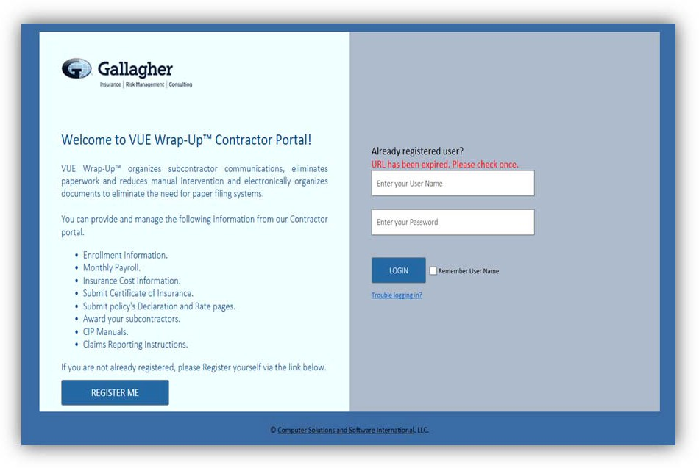

First time users please click here to register.

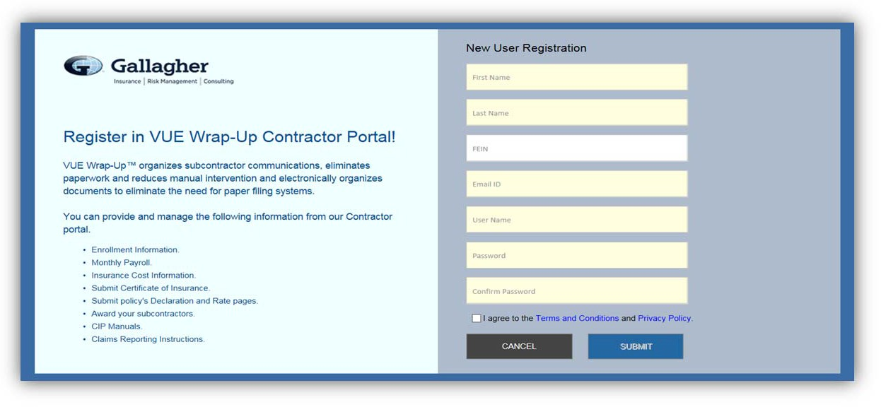

- Fill in the form with your first name, last name, email ID (email address) and enter the user ID you would like to use. Your user ID can be any name or phase you will easily remember, such as your first initial and last name (preferred), your company name, or your email address. Password must contain letters, numbers and symbols. All fields are required.
- When your registration has been completed successfully, you will see the message “User ID and Password are created”. Please click here to login to “Contractor Portal”. Click the link to be redirected to the login page where you can login to the portal to complete your enrollment. You will also receive an email with your User ID and Password for your records.

Use your provided or created User ID and Password to login. If any error messages appear, contact your AJG Wrap-up Administrator.

Step 2: Accessing Existing Enrollment or Adding a New Enrollment

- If your incomplete enrollment already has a contract in the system, you may be required to fill in the missing details. Your contract can be selected by clicking on the contract number hyperlink in the Contract # column.

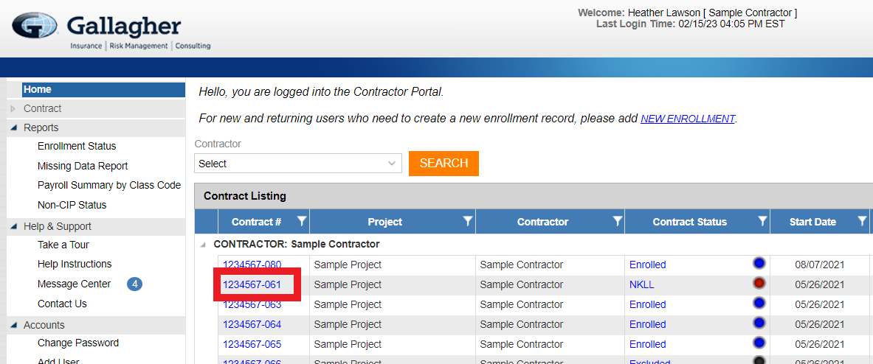

- If you do not see a contract for the specific project you are enrolling in, click the “New Enrollment” button.

- When the user clicks on the New Enrollment link, a pop up screen will open as shown below. Users should provide the Project Code as listed in their Wrap Up manual or provided by their Wrap Up Administrator.

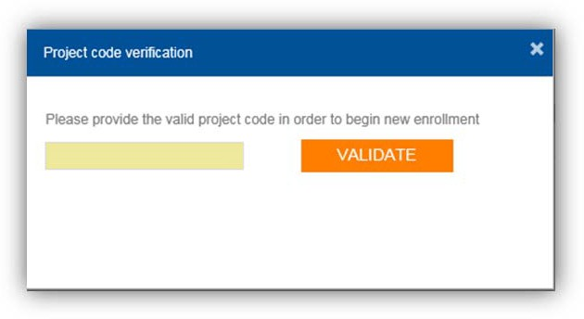

Step 3: Completing the Application for Enrollment

  - The Application For Enrollment includes the following sections, each of which can be accessed via the Menu on the left of the screen:

    - Company Information
    - Contract Information
    - Address Information
    - Contact Information
    - Additional Information
    - Subcontract Listing
    - Documents
    - Review
    - Non-CIP COI
    - Payroll
    - Documents
    - Close Out

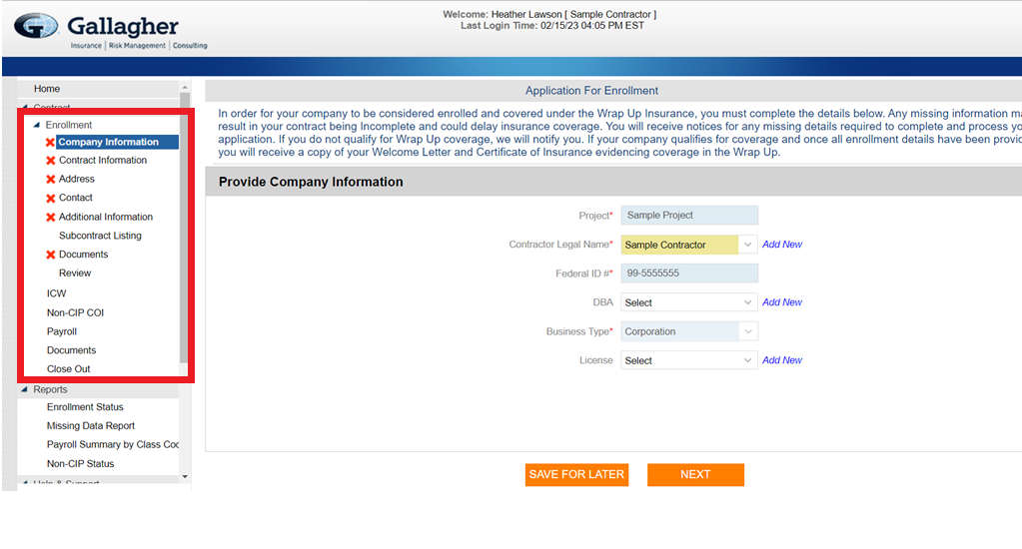
  - Fill in each section with your information to the best of your ability. Fields in yellow are required to submit the enrollment. For a new enrollment, all fields should be filled in. If a contract has been added to your portal by an AJG Wrap-up Administrator, you may not be able to edit some fields. If you notice a mistake in a non-editable field, contact your AJG Wrap-up Administrator and ask them to make the update.

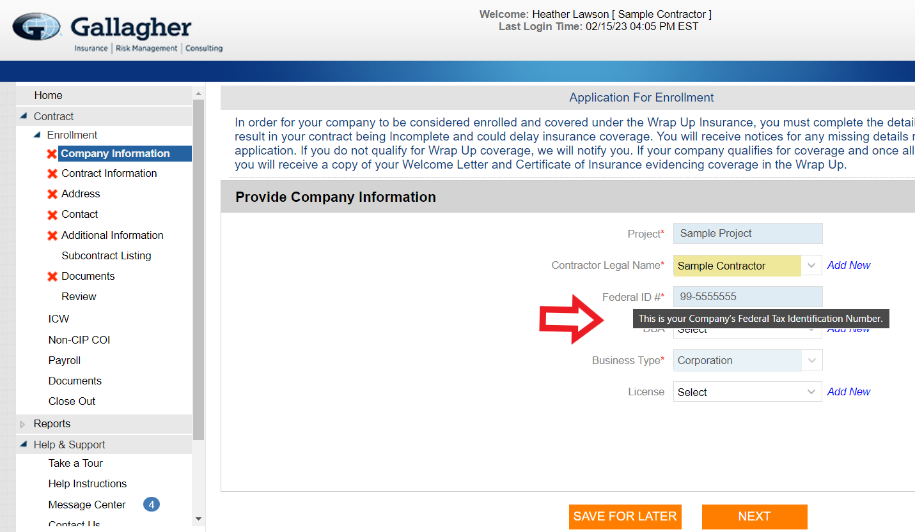

If you are not sure what a field is requesting, hovering over the field title will show captioned explanations.

    - Company Information – This information should prefill with the possible exception of the Federal ID #. You must enter your correct Federal ID # if it’s not there.
    - Contract Information – This information should be specific to this project and contract.
    - Address – Please provide your company’s address. If you have multiple addresses please provide the address for the branch that is responsible for the contract.

    - Contact - In the Contact section you must enter at least one contact and it must be marked as primary. You may also add additional contacts i.e. Payroll Contact or Worker’s Comp Claim Contact by clicking the green plus sign on the right side of the screen. If you have previous enrollments you can select Existing Contacts here.

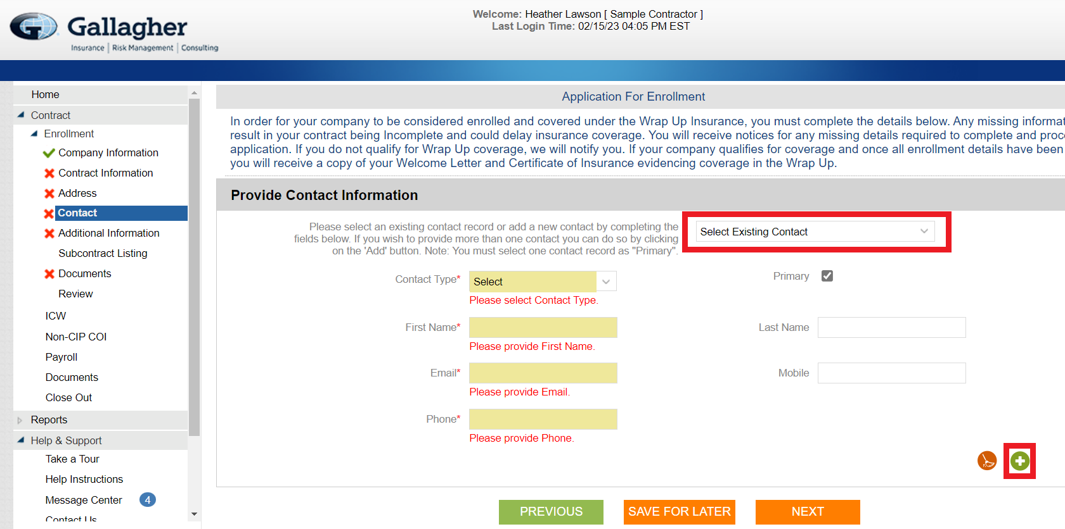

    - Additional Information – Provide requested information.
    - Subcontract Listings – You must add any on site Trade Contractor you have awarded. Trade Contractors must be enrolled separately. “Add Subcontract”, “Edit Subcontract”, and “Delete Subcontract” are available in blue on the right side of the screen:

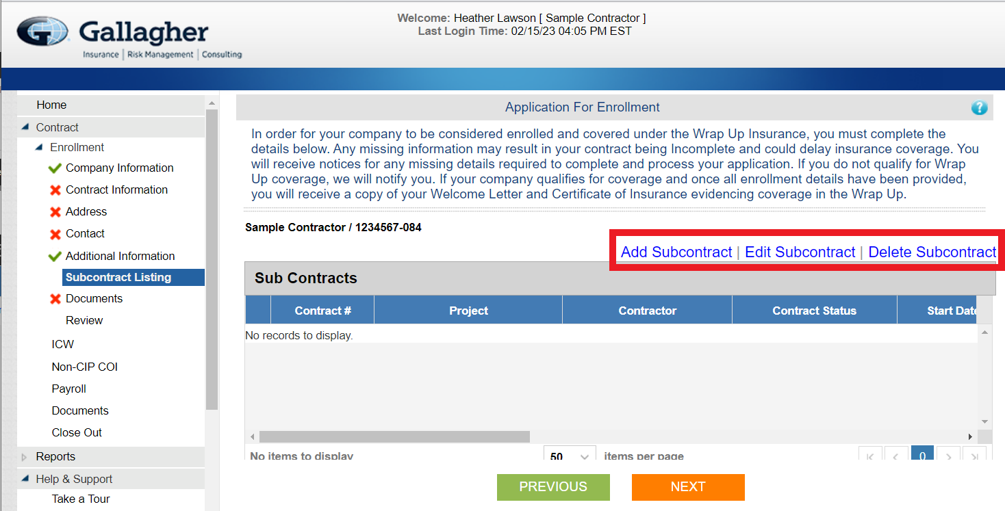

    - Documents – You will be required to provide Rating and Declaration Pages from your traditional General Liability, Excess Liability, and Workers Compensation Policies. Please upload any required documentation here. You may browse your computer to find the file or you may drag and drop to upload. Please choose the correct Form Type for each upload by clicking the appropriate box. Rate/Declaration pages are to be uploaded by the type of coverage (GL Rate/Dec Page, WC Rate/Dec Page, XS Rate/Dec Page):

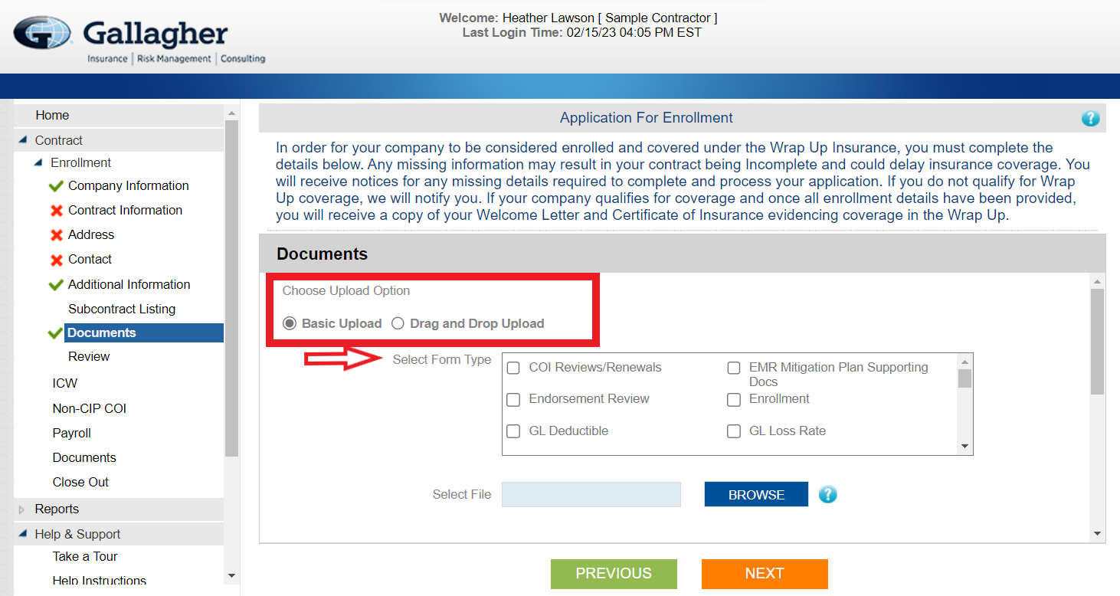

    - Review – Please review the information entered and any information needs revised click the orange “EDIT” button on the right side of the line. If everything is correct click the “I agree that the statements in this application are true and accurate to the best of my knowledge.” box and enter your name into the Signature box:

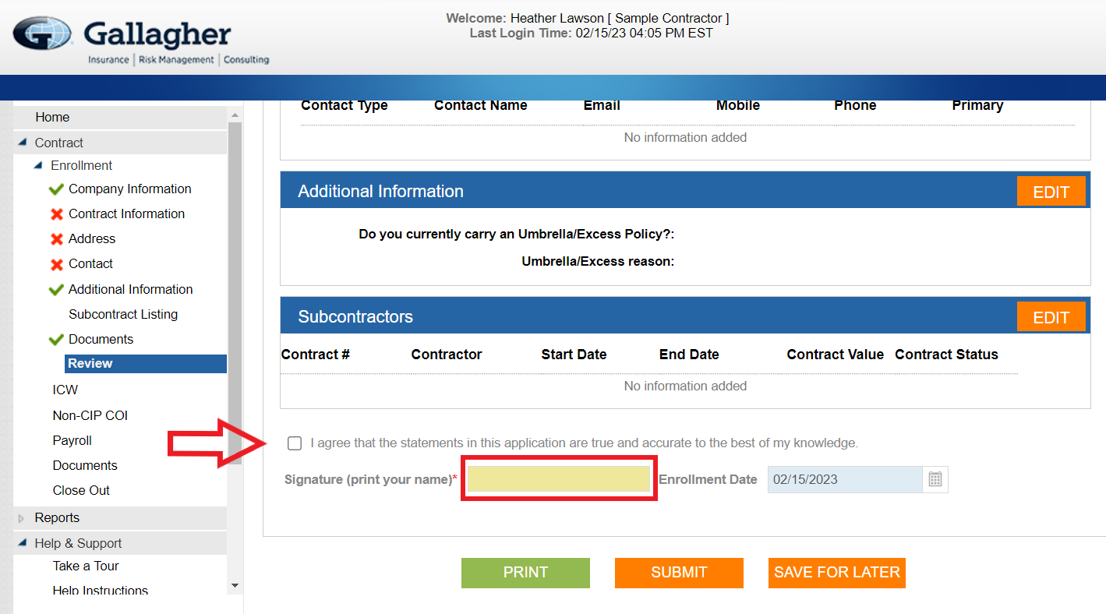

    - Non-CIP COI – If required, please enter your Workers Compensation policy information here.
    - Payroll – Please skip to Section 4: Payroll
    - Documents – You may enter any additional documents you didn’t submit above here.
    - Close Out – Please skip to Section 5: Close Out

Step 4: Reporting Payroll Online
Payroll is required to be submitted monthly online by all Trade Contractors on jobs that cover Worker’s Compensation.

- Once logged in to the portal site click on the Contract # listed on the Home Screen.

- When the Contract Summary pops up go down to the Onsite Payroll line and click the orange “GO TO DETAILS” button on the right:

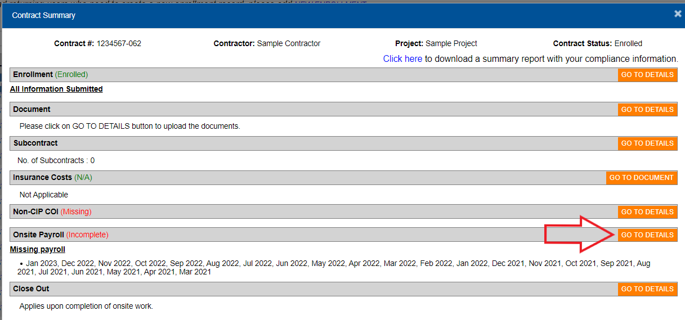

- The system will prefill the date of the last month. (Any dates in red, are delinquent payroll that must also be submitted. You can enter payroll for these dates by pressing them and filling in the information.)

- On the payroll screen, the WC Code(s) will be filled from the estimated payroll you submitted during enrollment.

- If you need to add another WC code, click on the blue plus (+) button located on the top right of the payroll chart. You can delete a selected WC Code by clicking the red Delete (x) icon located above the Reported Payroll column. Note: You must leave a note in the notes field explaining to the AJG Wrap-up Administrator why you are entering payroll for a class code not included on your enrollment.
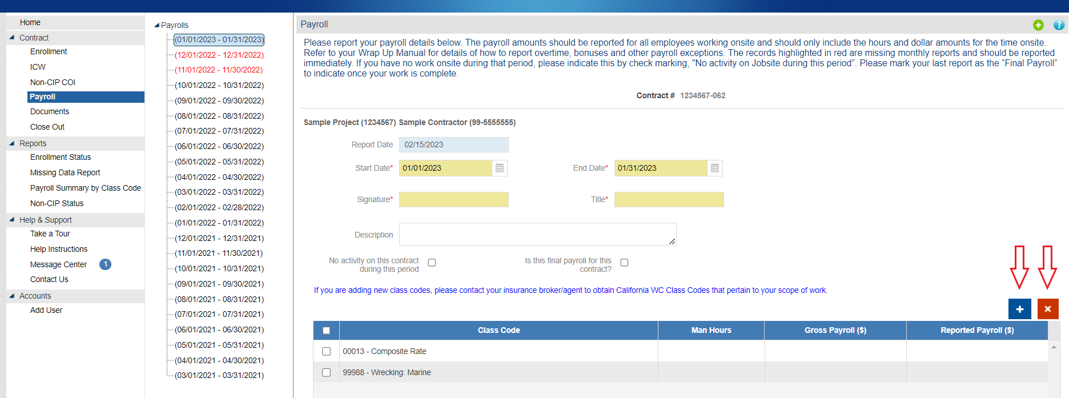

- Click the Man Hours field to enter the correct hours. Enter the Unburdened Payroll (straight time: no overtime premium, taxes, union dues, etc…)
  - Remember: If there are no hours worked for a WC code for that month, enter zero (0) in all fields
- If no time was worked on site for that month, please check box next to “check the No Activity on jobsite this period box” and submit.

- If you are entering Final Payroll, please check box next to “Is Final Payroll for contract?”

- After all required information has been entered, click the orange Submit button at the bottom of the screen. Please note: Once the payroll information has been submitted it is still editable and can be revised as needed. If you are unable to edit please contact the AJG Wrap-up AJG Wrap-up Administrator for changes.
- To print, click the green Print button on bottom of the screen next to the Submit button. A PDF file will open displaying the details of the submitted Actual Payroll.

Step 5: Close Out

- Once logged in to the portal site click on the Contract # listed on the Home Screen.

- When the Contract Summary pops up go down to the Close Out line and click the orange “GO TO DETAILS” button on the right.

- Please fill out all fields on the Contract Close Out screen.
  - Date Onsite Work was completed - The day your company finished work on site.
  - Completion Signature - The name of whomever is completing the form
  - Final Contract Value - Your final contract value with you Trade Contractor
  - Payroll Information - The final payroll amount for all Class Codes from your enrollment, for the entire project. NOTE: The payroll box will auto fill with the totals from your monthly payroll submissions. If the total does not match, you must go through your reported payroll for each month and edit as necessary. Once you have edited you may press the “Refresh Payroll” button and submit.
  - Sub Contractor Details – Please review your subcontractors and enter their final contract value.
  - Are there any Trade Contractors that you hired for this project that are not listed above as EXISTING SUBCONTRACTORS? – Please select “Yes” or “No” in the drop down.
  - Add Subcontracts – Please use the blue plus (+) button to add any Trade Contractors not listed above in the Sub Contractor Details list.

